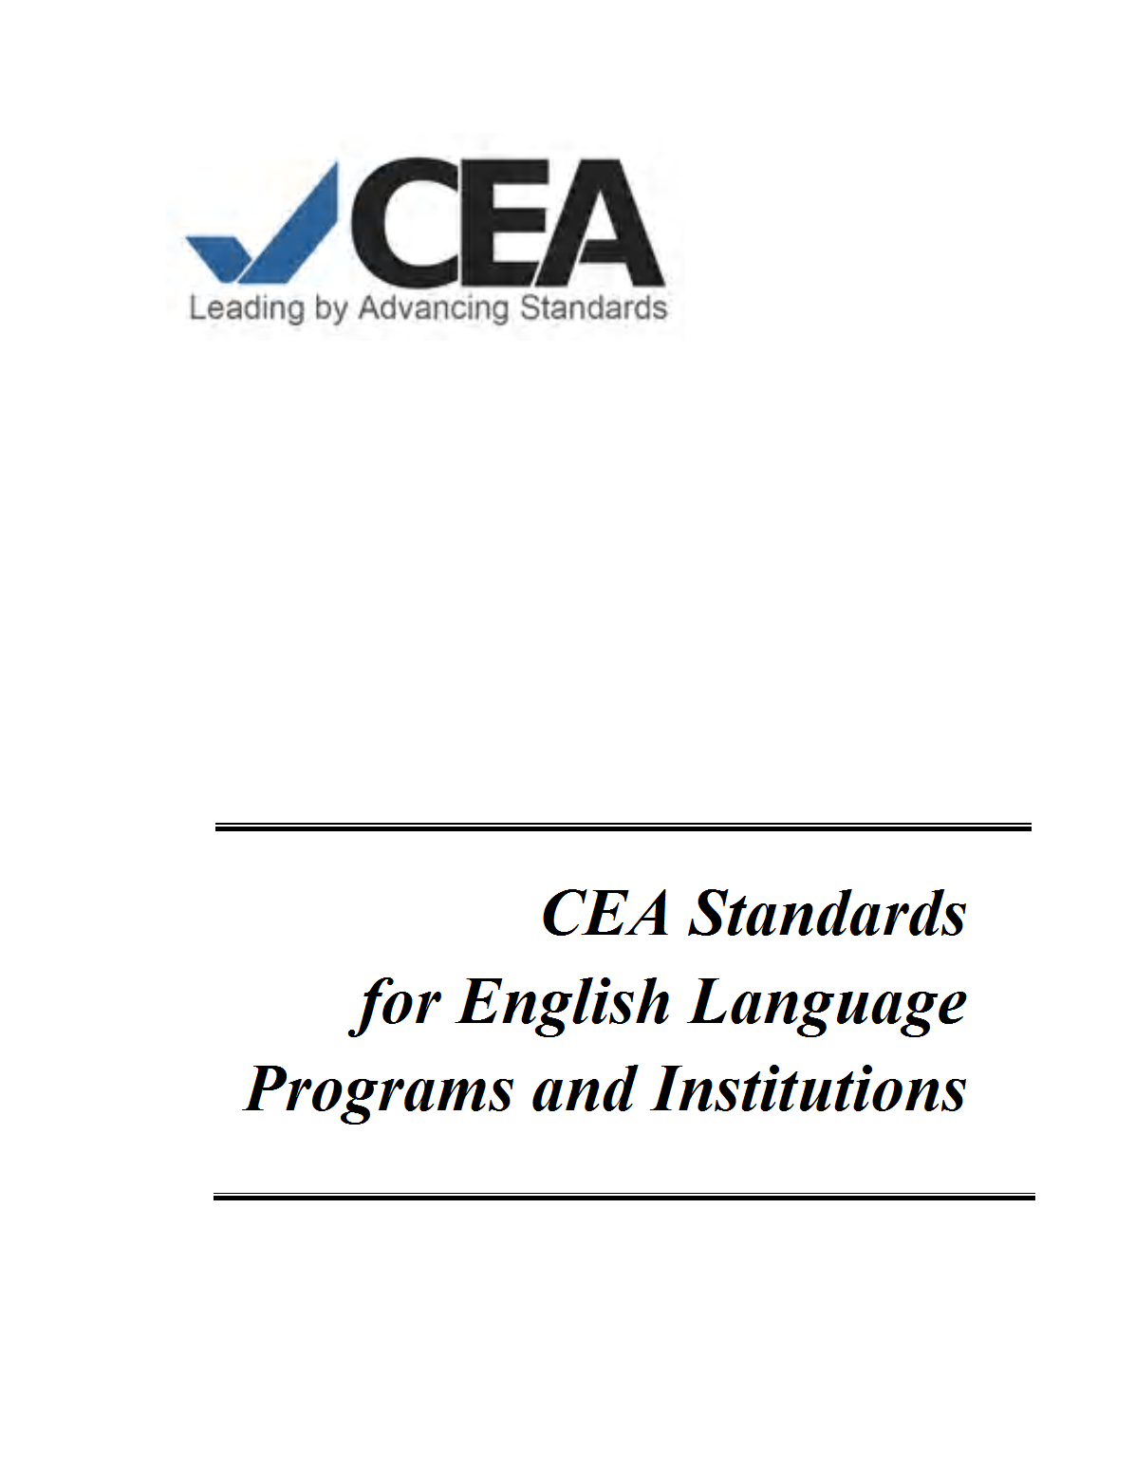

August 2011

Monette ANDERSON

August 2011

Galyna ANDRYUSHCHENKO

August 2011

Jenny ARBAI

August 2011

Natalya ARMYAKOVA

August 2011

Zukhra BATCHAEVA

August 2011

Tetiana BOBRYSHEVA

August 2011

Olesya BRAZHNIKOVA

August 2011

Freddie Ann BUSH

August 2011

Eligio CASTILLO

August 2011

Myriam CHALEK

August 2011

Ana Margarita DIAZ

August 2011

Gladys DIAZ

August 2011

Dr. Leonilda DOLINA

August 2011

Loreen DOLINA RUCK

August 2011

Lina ECO

August 2011

Christian GALLARDO

August 2011

Libertad GRAJO

August 2011

Edwin GUEVARA

August 2011

Yana KIRYEYEVA

August 2011

August 2011

Erlinda MANLICLIC

August 2011

Melvin MARCUS

August 2011

Madina MARZHOKHOVA

August 2011

Zoryana MATIYCHYK

August 2011

Semen MERE-MERE

August 2011

Enrique NIBEYRO

August 2011

Vicenta ORTIZ

August 2011

Nori PANGANIBAN

August 2011

Anna PLINER

August 2011

Emiliano RAMOS

August 2011

Karina RODRIGUEZ

August 2011

Ivelisse RYMER

August 2011

Svetlana Shcheglova

August 2011

Alumna TULDANES

August 2011

August 2011

August 2011

August 2011

August 2011

August 2011

August 2011

Rasha ABD EL RASOL

August 2011

Chi-Chieh Chiu

August 2011

Drissa COMPAORE

August 2011

Iliyana DIMITROVA

August 2011

Dilyara ENGULATOVA

August 2011

Anvar ERGASHEV

August 2011

Angie GOMEZ

August 2011

Mary Helen GOMEZ

August 2011

Alfiya KHALIKOVA

August 2011

Lyudmila KLAVSEN

August 2011

First NAME Last NAME

August 2011

Ildelisa LOPEZ

August 2011

Maria MACHADO

August 2011

Zoryana MATIYCHYK

August 2011

Marina NISIMOV

August 2011

Dr. Carolyn PRAGER

August 2011

Paul SCHIFFMAN

August 2011

Thomas SCHWENKE

August 2011

Svetlana SERGEEVA

August 2011

Benjamin TAGNAN

August 2011

August 2011

Carmen VARGAS

August 2011

Bouchra ZOUHAIRI

August 2011

August 2011

August 2011

