Student Counseling Plan

2009 - 2013

Spanish-American Institute
215 West 43 Street
Times Square, New York 10036-3913

Table of Contents
Table of Contents 2
I. The student's ability to progress in the curriculum. 4
How is the determination made that a student is not progressing in the curriculum? 4
At what intervals will the student's progress be evaluated? 4
Who will make this determination? 4
What will be provided to the student in this area? 4
When will this information be provided to the student? 5
How will this information be provided to the student? 5
Will remediation be available for students who are not adequately progressing in the curriculum? 5
II. The student's financial aid rights and responsibilities. 6
What will be provided to the student in this area? 6
When will this information be provided to the student? 6
Who will provide this information to the student? 6
III. Availability of programs to earn a high school equivalency diploma including programs provided at no cost to the student. 7
What will be provided to the student in this area? 7
When will this information be provided to the student? 7
Who will provide this information to the student? 7
Identify what the student must do in order to pursue a high school equivalency program at no cost. Identify an appropriate contact person or organization for the student. 7
IV. Potential of the training to prepare the student for available employment opportunities within the region. 8
What will be provided to the student in this area? For example, will there be: 8
When will this information be presented to the student? 8
Who will provide this information to the student? 8
Identify any additional training, licensing examinations or registration necessary to secure employment in this particular field. 9
V. On placing students on academic probation. 10
What criteria will be used to place a student on probation? 10
Who will make this determination? 10
When will this information be provided to the student and in what format? 10
Who will provide this information to the student? 10
What does the student need to do in order to be removed from probation? Submit a copy of student progress forms, if applicable. 10
VI. Other - Counseling 11
What will be provided to the student in this area? 11
When will this information be provided to the student? 11
Who will provide this information to the student? 11
VII. documentation on how the school documents delivery of the counseling services to the student. All such documentation is required to be placed in the student's file. 12
COUNSELING PLAN APPENDICES 13
List of Human Resources Administration Office of Employment Services Training-Related Services Locations 13
Grade Record Card 14
Personal Data Card for Students with Sample Program 15
Sample Attendance Letter 16
Drug Prevention and Information Program Statement of Commitment 17
Sample Absence Alert Notification Letter 18
Sample Counselor’s Attendance Letter 18
Sample Student Absence Alert Notice 19
Sample Student Academic Alert Notice 19
Sample Academic Probation Letter 20
ATB Academic-Personal-Career Advising Form 21
Adult Basic Education Program High School Equivalency Preparation Classes List 22
Academic Warning Letter 24
Progress Report Sample 25
Program Exit Interview Form for GSL Students 26
Sample Program Planner Form 26

I. The student's ability to progress in the curriculum.

How is the determination made that a student is not progressing in the curriculum?
A student who does not achieve a grade of at least 65% in examinations and does not attain a cumulative average of not less than 70% (Grade Point Average of 2.0) is not considered to be in good academic standing. There are six grade reporting periods in one year.
At the halfway point of the maximum time frame of the program, the student's progress is evaluated to determine that at least 60% of the class hours attempted toward the educational objective have been completed with a minimum 1.5 grade point average. The maximum time frame in which a student must complete his/her educational objective is 1.5 times the standard program length for normally progressing students of the same enrollment status.

At what intervals will the student's progress be evaluated?
• Examination grades are reviewed bimonthly.
• An instructor can file an Academic Alert Notice (see appendix A) with the Dean of Students for immediate intervention at any time a student is not performing to standards.
• Final grades for each course are reviewed at the completion of each course.
• Satisfactory progress is measured each academic year and at the halfway point of the maximum time frame of the student's program.

Who will make this determination?
The Dean of Students is responsible to make the determination that the student is progressing through the curriculum. All questions regarding the student's progress through the curriculum are referred to the Dean of Students by the student's advisor.

What will be provided to the student in this area?
The student is provided with his/her individual "Program Planner" (see appendix B) at her/his initial orientation session which is up-dated as course changes take place in her/his program. The Program Planner shows the starting and ending date of each course the student is currently taking, as well as, final grades for each completed course. In the initial orientation session, the student is advised on the program components, academic and time requirements for satisfactory completion of the components, and the availability of extra help, if needed. As each course is completed the advisor counsels the student with regard to the next sequence of courses. If the student fails to report for his/her scheduled program up-date, the advisor will go the student's class and personally bring the student to the office for the scheduled course change.
An individual "Program Up-date" form (see appendix C) is provided to the student each time a course change takes place.
A Progress Report, report card, (see appendix D) is issued to the student after each bimonthly examination period.

When will this information be provided to the student?
The student is provided information on his/her progress throughout the program beginning during the first week with the Orientation session and continuously to the end of the program with scheduled course up-dates. The interval between scheduled conferences varies, depending on course length (usually 6 to 8 weeks).
The Progress Report is provided approximately two weeks after the end of the examination period.
Academic warnings (see appendix E) are sent out on the day Progress Reports are issued.
Failure to maintain Satisfactory Progress is presented at the time of determination.

How will this information be provided to the student?
The student's progress through the curriculum is provided in personal conference with the advisor, through the up-date of the Program Planner, and on the Program Up-date form each time the student has a conference with his/her advisor.
Examination grades are furnished on the Progress Report.
Failure to maintain Good Academic Standing is reported to the student by an Academic Warning letter mailed to the student's home.
Notice of failure to maintain Satisfactory Progress is provided in a personal interview with the Dean of Students.

Will remediation be available for students who are not adequately progressing in the curriculum?
Remediation is provided for students who are not progressing adequately in the curriculum. A student who receives an Academic Warning in a course is offered additional class time beyond their regularly scheduled classes and teacher coaching in an effort to overcome deficiencies.

II. The student's financial aid rights and responsibilities.

What will be provided to the student in this area?
Students interested in financial aid are provided with information on the programs available, both Federal and State. Standard consumer pamphlets and fliers provided by state and federal agencies are available in the student lounge Resource Center.
Applications for Pell, Tap, and Stafford Loans are available. Students are assisted in filing applications to the programs to which they may qualify.

When will this information be provided to the student?
Information on financial aid rights and responsibilities is provided at the time the student is applying for admission to the Institute. Institute personnel advise each prospective student individually.
In the event a student wishes to apply for a loan he is advised of his/her responsibility to repay the loan, at the time of the application, at the time of disbursement, and in the exit interview (see appendix F) either upon completion or withdrawal.
At the initial disbursement of loan proceeds, the President reviews the students rights and responsibilities.
The exit interview, with the Dean of Students, takes place approximately two months before the completion of the program or at the time of withdrawal from the program. In the event the student withdraws without notice and a personal interview is not possible the exit interview information is mailed to the student.

Who will provide this information to the student?
The Dean of Admissions, the President, and the Dean of Students provide information on students financial aid rights and responsibilities to the students.

III. Availability of programs to earn a high school equivalency diploma including programs provided at no cost to the student.

What will be provided to the student in this area?
ATB students (i.e. non-high school graduates / non-GED holders admitted to programs under the Institute's "Ability to Benefit" procedures) are provided with a list of contacts in New York City, for High School Equivalency Preparation Programs offered through the NYC Board of Education.

When will this information be provided to the student?
At the time the student's Application for Admission is reviewed by the Dean of Admissions the ATB student is advised of the availability of the GED Preparation classes.
During the first week of the program when the student has Orientation with his/her advisor, if the student is not enrolled in the GED classes he is advised on the importance of a High School Diploma and given a strong recommendation to enter the class. The advisor will continue to urge the student to take the preparation throughout the program in subsequent sessions.

Who will provide this information to the student?
Information on availability of the GED Preparation classes is provided by the Dean of Admissions, the student's advisor, and the Dean of Students.

Identify what the student must do in order to pursue a high school equivalency program at no cost. Identify an appropriate contact person or organization for the student.
In order to pursue the GED Preparation classes at no additional cost, the student need only call one of the contacts from the list to receive information on class schedules, schedule a reading examination with the center he chooses, and go. A list of contacts is found in Appendix G.

IV. Potential of the training to prepare the student for available employment opportunities within the region.

What will be provided to the student in this area? For example, will there be:
• employment counseling
• referrals for interviews
• information on interviewing skills and/or
• resume preparation?

New students are scheduled for a meeting with the Placement Advisor to discuss the potential of the training which they are taking to prepare them for the available employment opportunities. They are informed of the placement assistance offered by the Institute.
Approximately 60 days prior to completion, students are registered for placement assistance and begin the placement process. They are assisted in final preparation of their resume, potential interview situations, and job placement based on their strengths and weaknesses.
One to one sessions with the Placement Advisor are conducted to reinforce job interview skills. Post-job-interviews are held to find weaknesses and strengths discovered during actual interviews.
Names and addresses of potential employers are supplied to students with the intent being to match the individual student and job skills of the student to the job requirements of the employer. The student is also recommended to employment agencies, which charge no fee to the student, in order to broaden the base of available job offerings.

When will this information be presented to the student?
The initial meeting of student and Placement Advisor will take place within 60 days of the start of the student's program.
Approximately 60 days before completion of their program placement registration and the placement process begins.

Who will provide this information to the student?
The Graduate Placement Advisor is responsible for providing this information to the students.

Identify any additional training, licensing examinations or registration necessary to secure employment in this particular field.
Students need no additional training, licensing examinations, or registration in order to secure employment at the entry level for any program offered at the Institute.

V. On placing students on academic probation.

What criteria will be used to place a student on probation?
Students who receive a cumulative average below 70% (Grade Point Average below 2.0) will be placed on Academic Probation for eight weeks and are expected to improve their grades in the next examination period.

Who will make this determination?
The Dean of Students is responsible for reviewing bimonthly examination grades and final grades issued to students and determines if a student should be placed on academic probation.

When will this information be provided to the student and in what format?
The student is informed after each bimonthly examination by the Dean of Students. The student is sent a letter (see appendix H) informing him of his/her status and advising him to report to the Dean of Students in order to develop a plan of corrective action through additional classes, extra homework, if arrangements can be made a peer tutor, and if applicable improved attendance.

Who will provide this information to the student?
The Dean of Students provides the student with this information.

What does the student need to do in order to be removed from probation?
Submit a copy of student progress forms, if applicable.
In order to be removed from Academic Probation, a student must raise his/her cumulative grade point average above 70% or provide information relating to mitigating or special circumstances related to academic probation within three weeks of being placed on academic probation. Information provided by the student is reviewed by the Academic Probation Appeals Committee consisting of the Institute's deans and a determination is made within ten days of the student's written appeal.

VI. Other - Counseling

What will be provided to the student in this area?
Attendance counseling is provided to any student who is absent from class for three consecutive days. Through the Absence Alert Notice (see appendix I), instructors inform office personnel and the student is immediately contacted by phone or if no phone is available an attendance letter (see appendix J) is sent. Students absent without leave for a week or more but less than 30 days are sent a letter requesting an immediate conference with the Dean of Students by phone or in person.
Personal advisement with regard to problems outside the school which may affect the student's ability to make satisfactory progress is provided as needed. Information on Social Service programs such as: WIN Program - for assistance with lunch money, carfare, and child care expenses and Office of Employment Services: Work Related Benefits - for continued public assistance after completion of studies and beginning to work, is made available to students in need.
Drug and alcohol abuse are addressed through the Institute's Drug Prevention and Information Program (see appendix K).

When will this information be provided to the student?
• Attendance counseling takes place as necessary.
• Personal advisements are done at the student's request when a problem is brought to the attention of an advisor.
• Drug and alcohol counseling is done at admission, addressed in class, and on an individual basis as needed.

Who will provide this information to the student?
Attendance is addressed by the instructor, the student advisor, administrative assistants, and the Dean of Students.

VII. documentation on how the school documents delivery of the counseling services to the student. All such documentation is required to be placed in the student's file.
Depending on which type of counseling has taken place, documentation of delivery of the above referenced counseling is recorded on the student's
- Personal Data card (see appendix L)
- Grade Record card (see appendix L)
- Academic-Personal-Career Advising Record Form for ATB Students (see appendix M)
- Financial Aid Folder

COUNSELING PLAN APPENDICES
Self-Study contains this Appendix Table of Content Actual samples, available from the Dean of Students, are not included with this self-study

List of Human Resources Administration Office of Employment Services Training-Related Services Locations
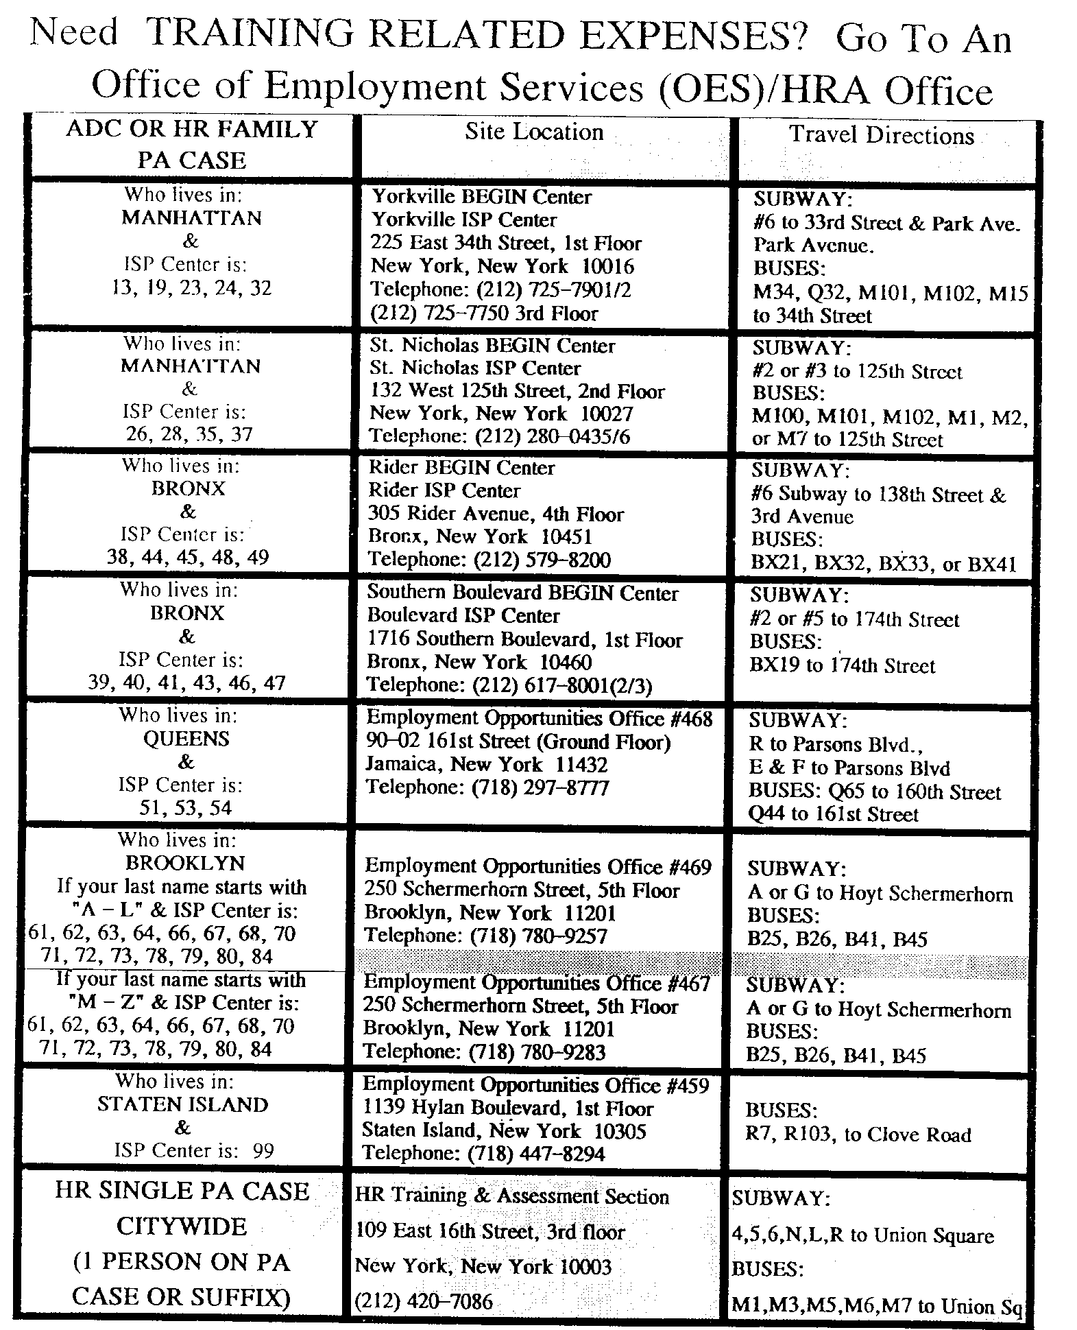
Figure 1 List of Human Resources Administration Office of Employment Services Training-Related Services Locations

Grade Record Card
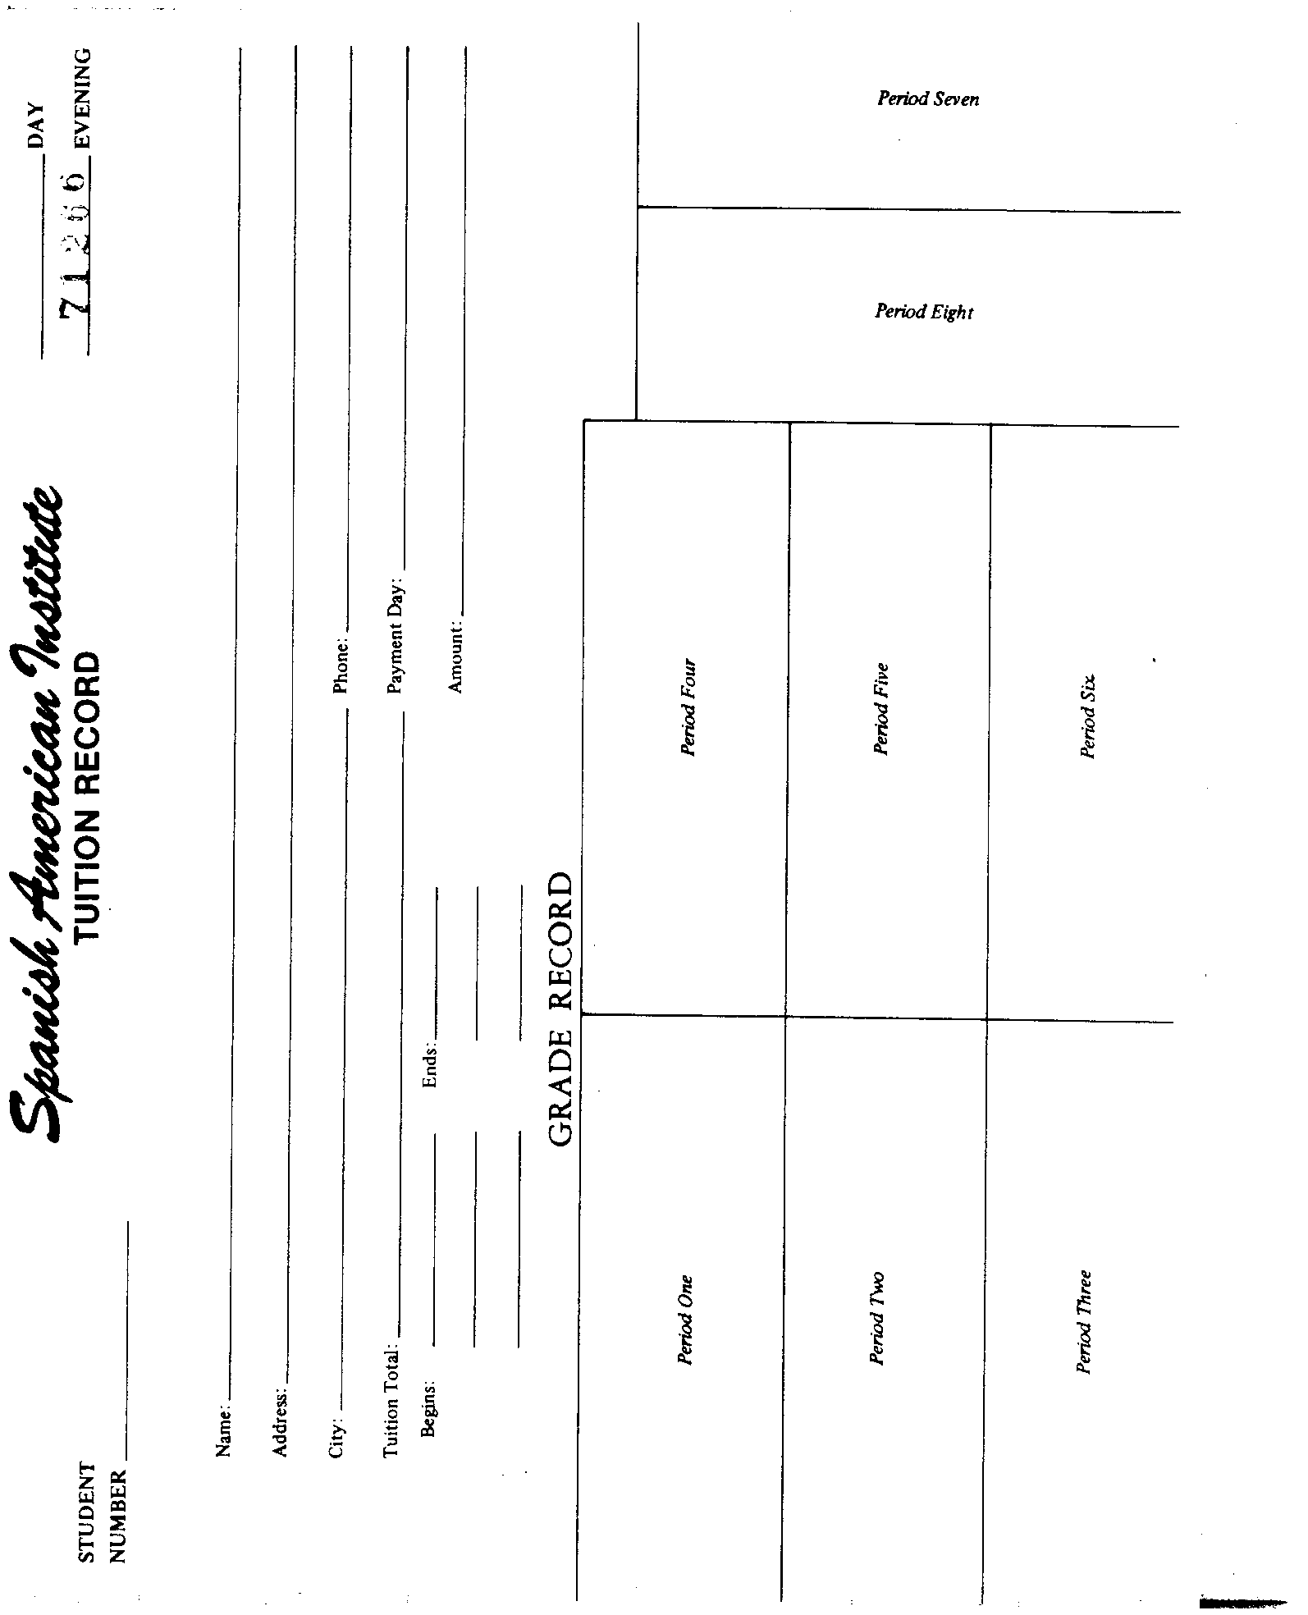
Figure 2 Grade Record Card

Personal Data Card for Students with Sample Program
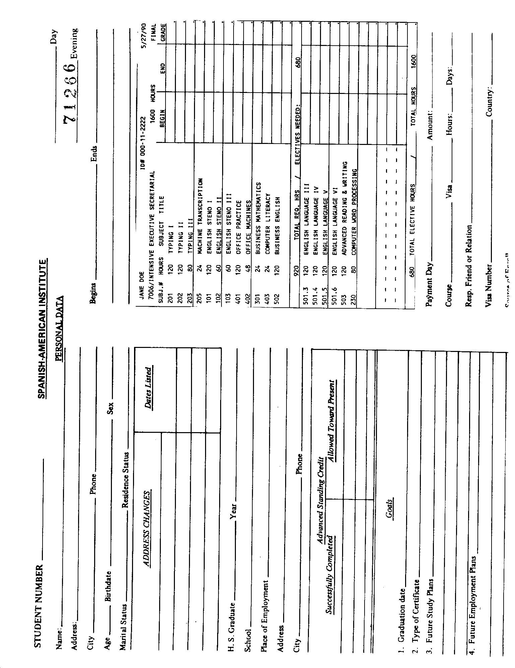
Figure 3 Personal Data Card for Students with Sample Program

Sample Attendance Letter
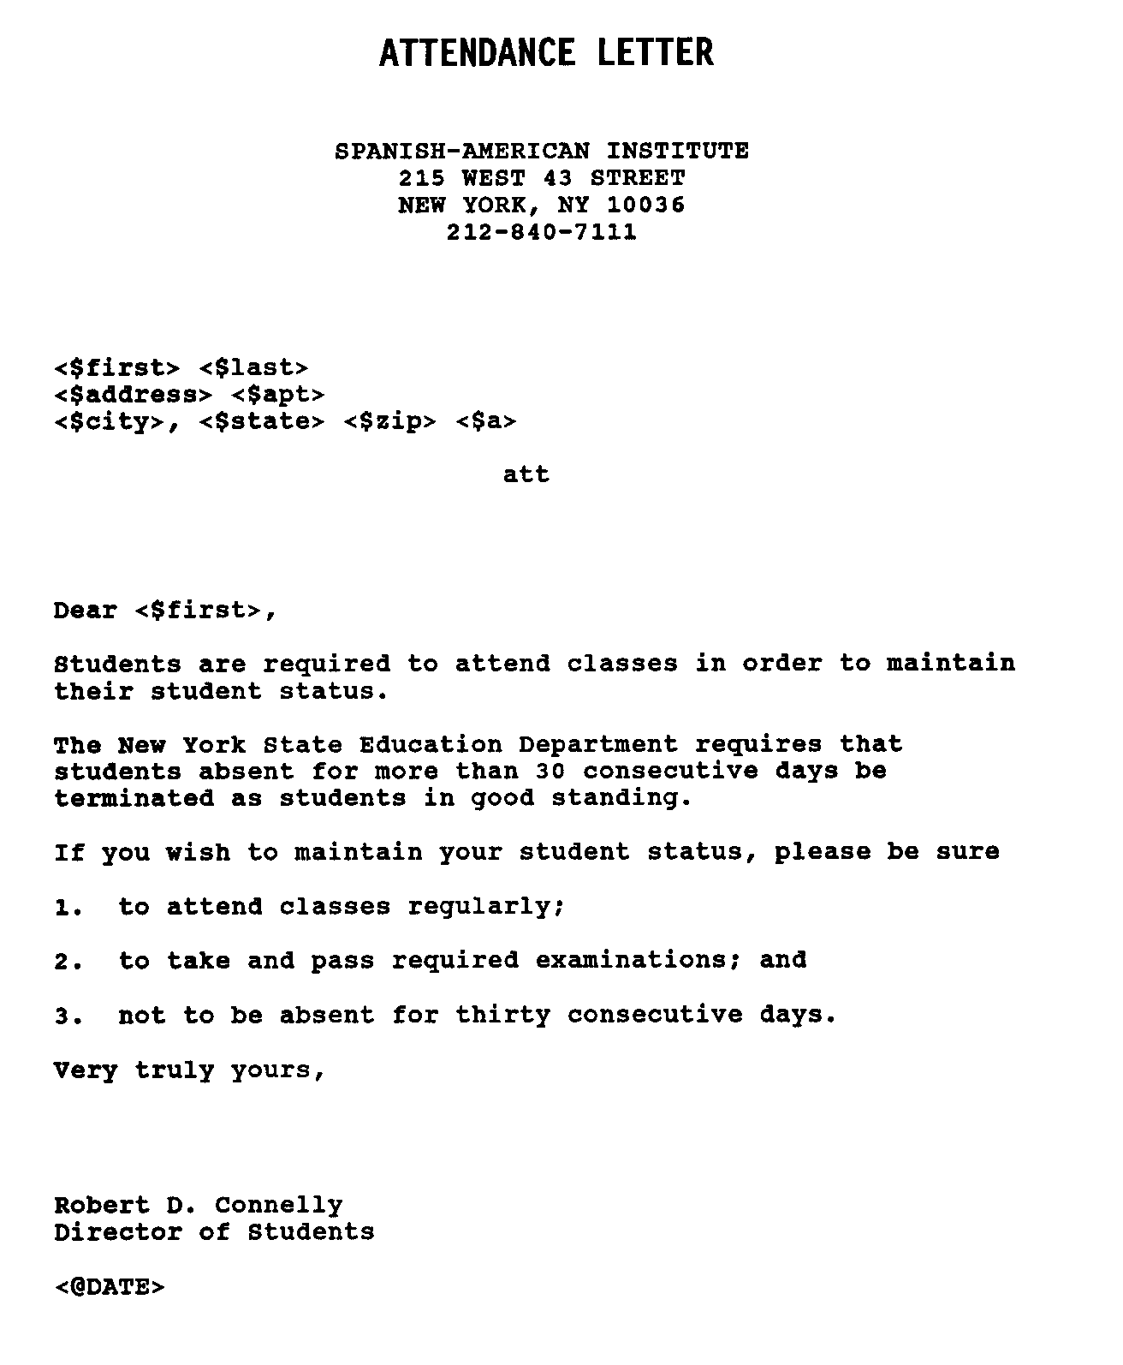
Figure 4 Sample Attendance Letter

Drug Prevention and Information Program Statement of Commitment
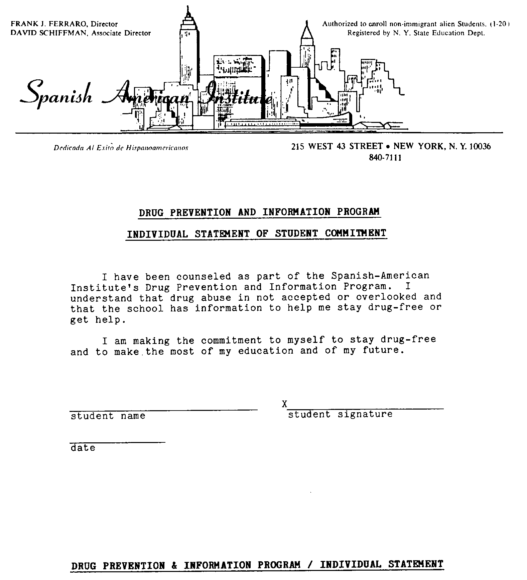
Figure 5 Drug Prevention and Information Program Statement of Commitment

Sample Absence Alert Notification Letter
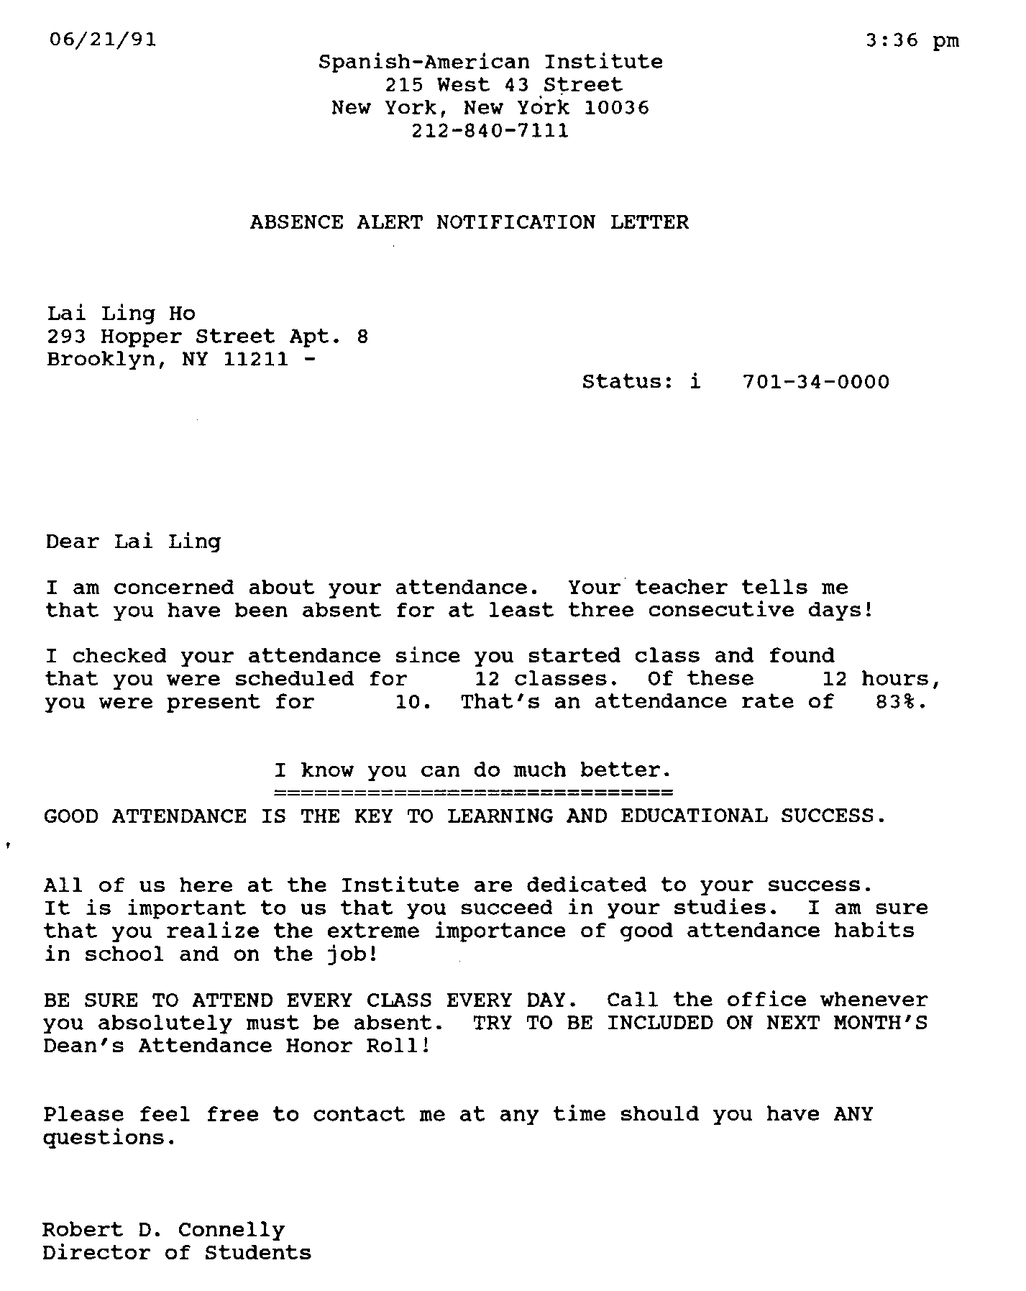
Figure 6 Sample Absence Alert Notification Letter

Sample Counselor’s Attendance Letter

Sample Student Absence Alert Notice
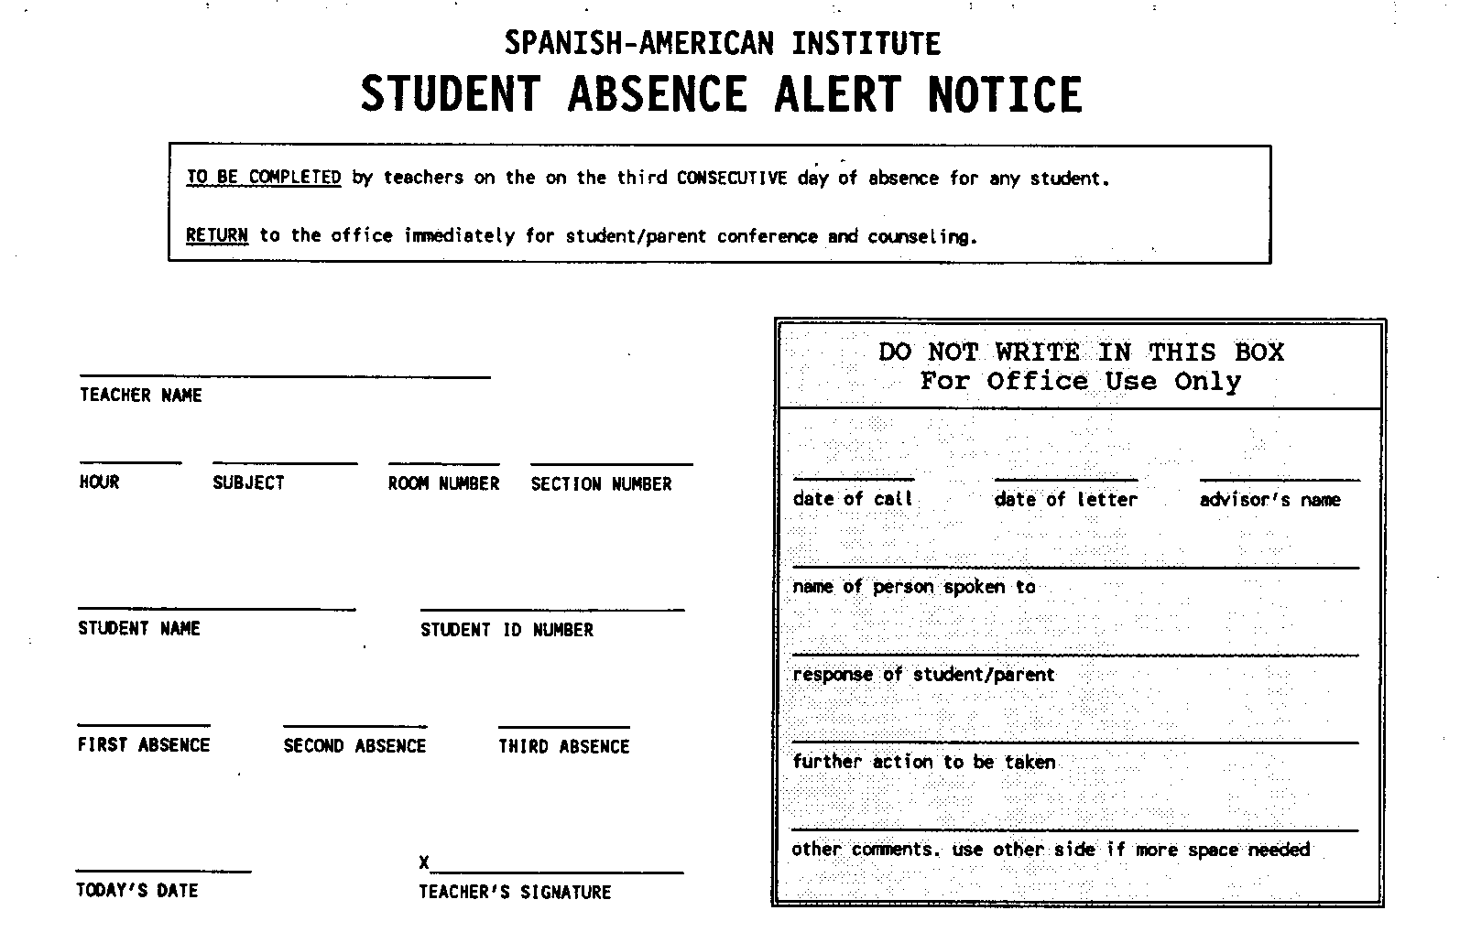
Figure 7 Sample Student Absence Alert Notice

Sample Student Academic Alert Notice
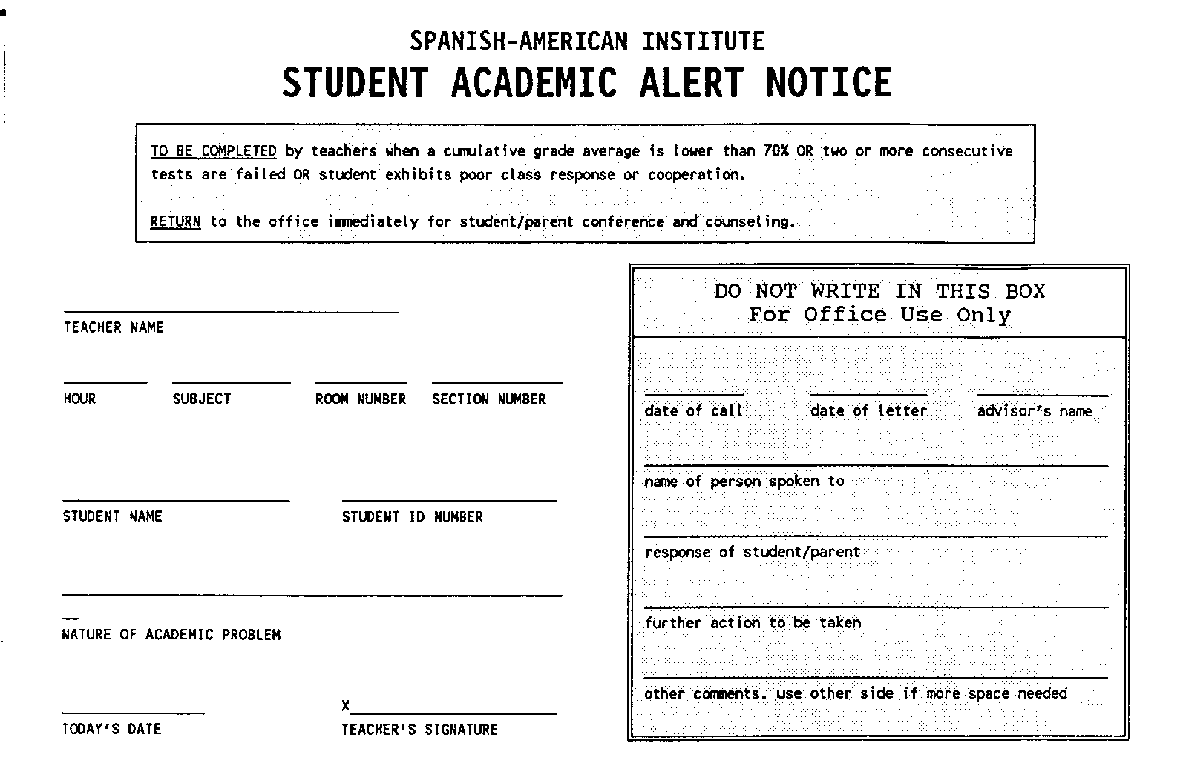
Figure 8 Sample Student Academic Alert Notice

Sample Academic Probation Letter
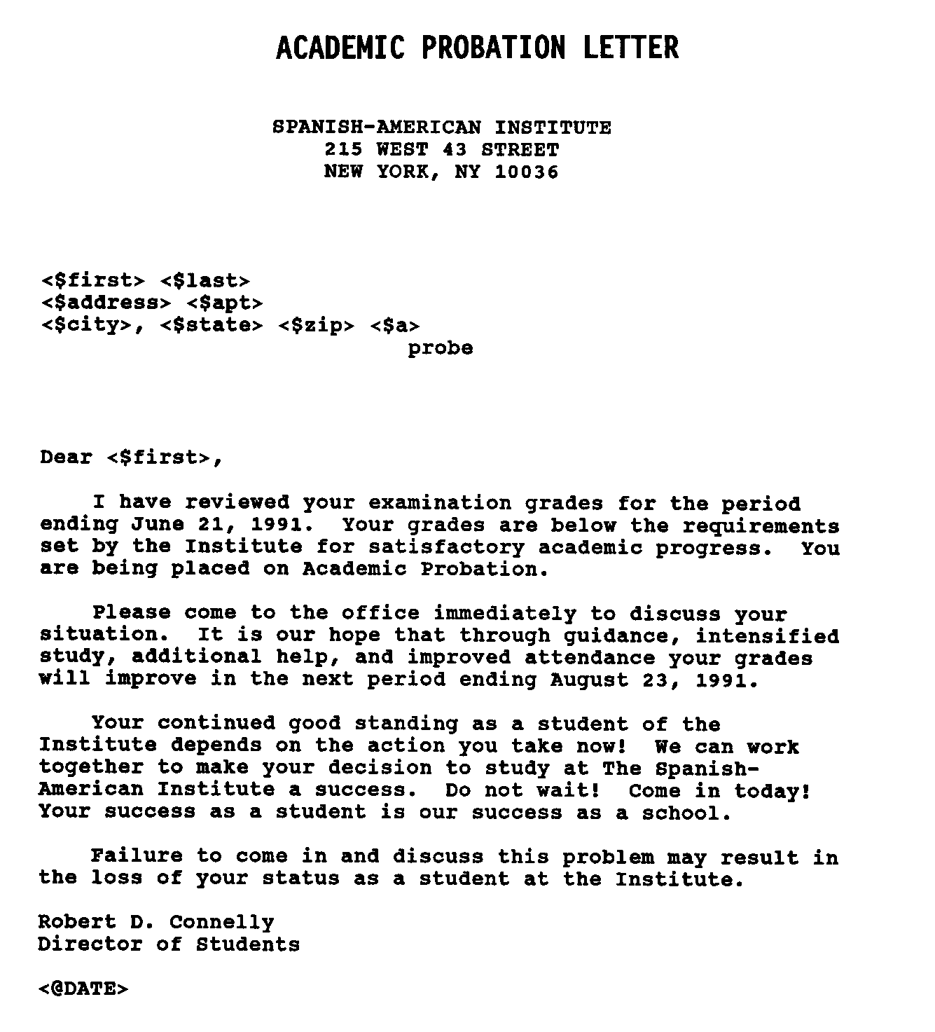
Figure 9 Sample Academic Probation Letter

ATB Academic-Personal-Career Advising Form
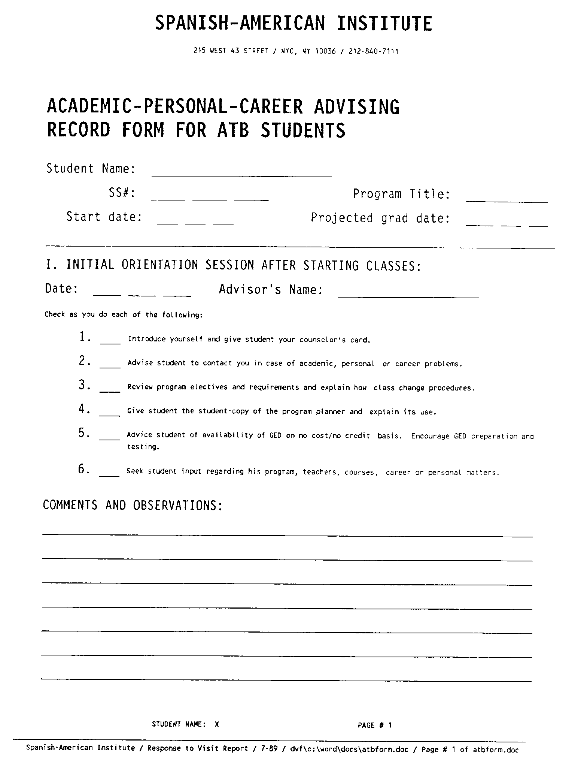  Figure 10 Page 1 of 4 ATB Academic-Personal-Career Advising Form | 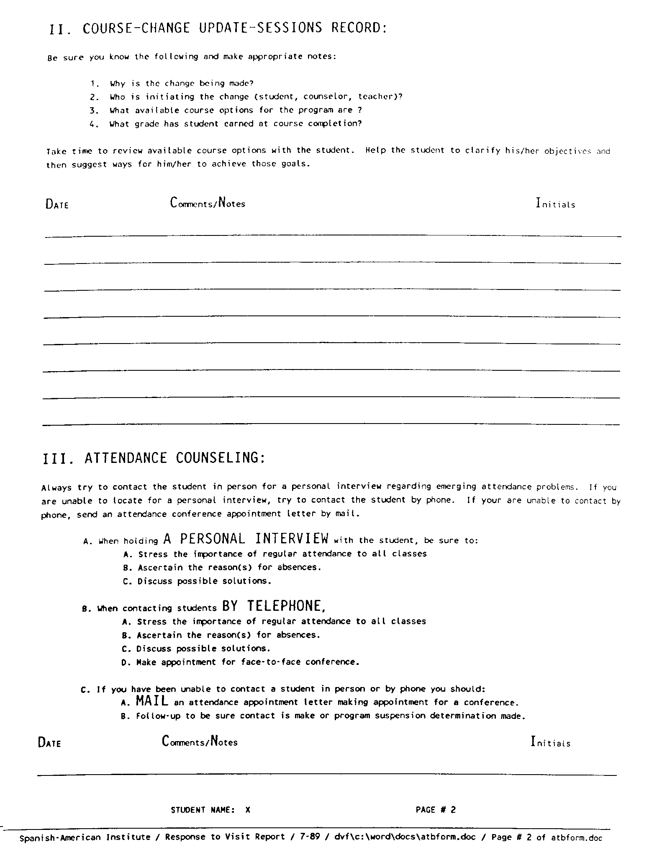  Figure 11 Page 2 of 4 ATB Academic-Personal-Career Advising Form
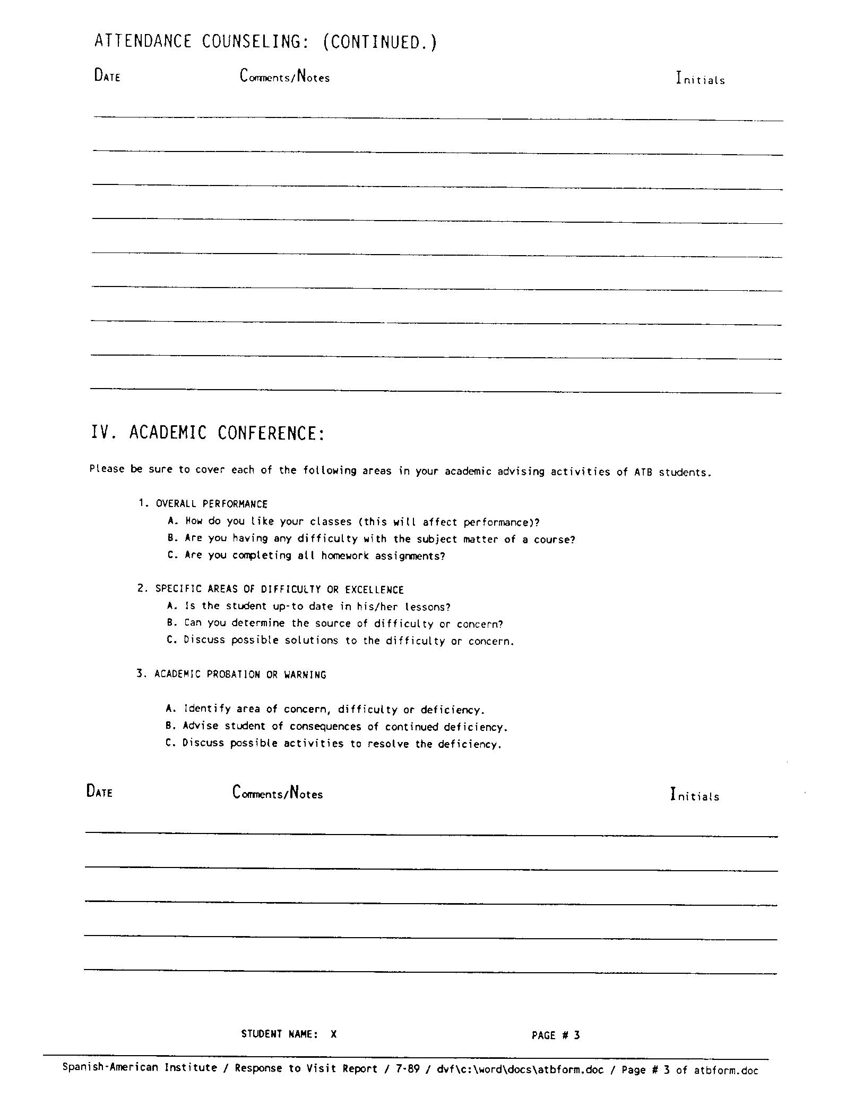  Figure 12 Page 3 of 4 ATB Academic-Personal-Career Advising Form | 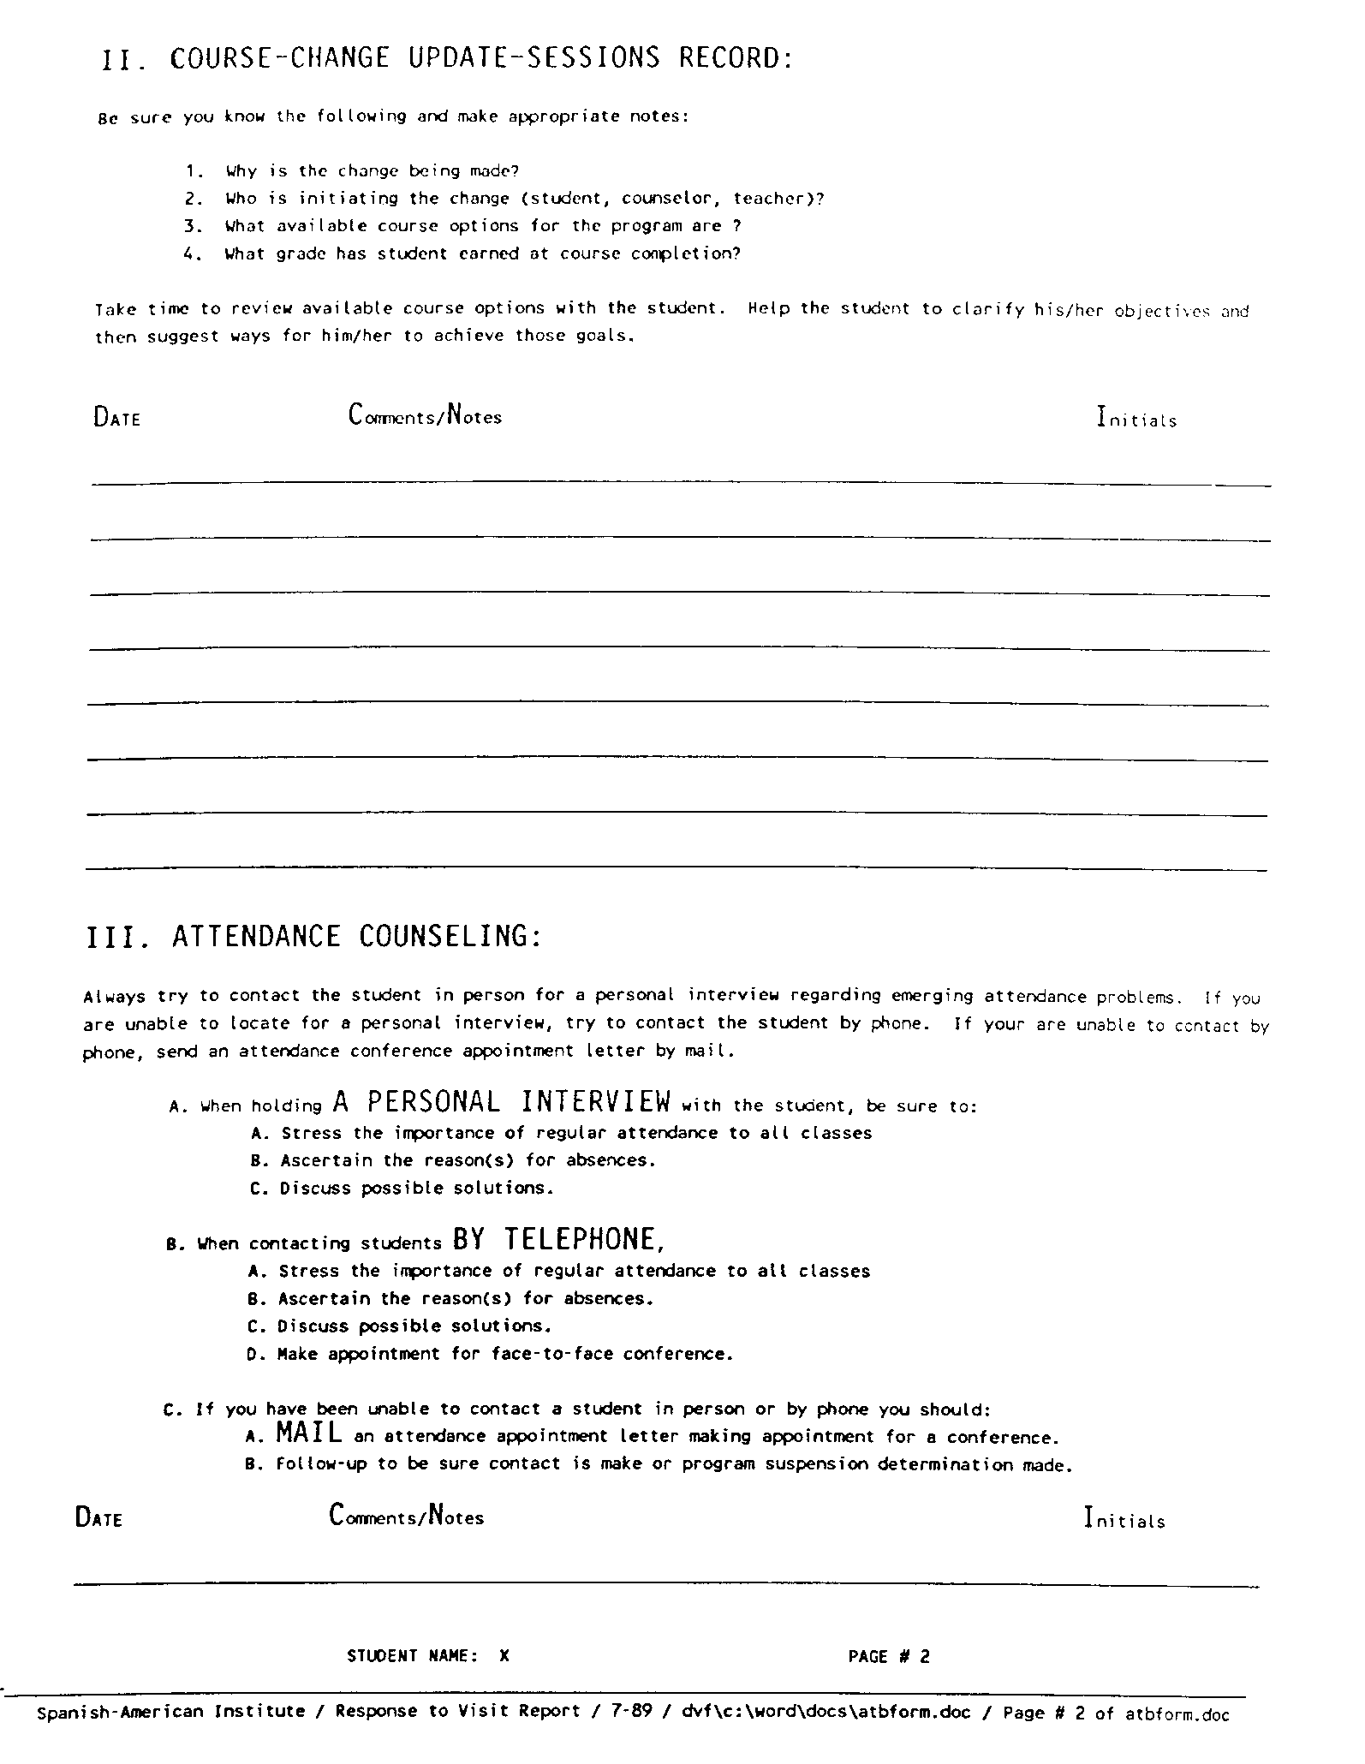  Figure 13 Page 4 of 4 ATB Academic-Personal-Career Advising Form

Adult Basic Education Program High School Equivalency Preparation Classes List
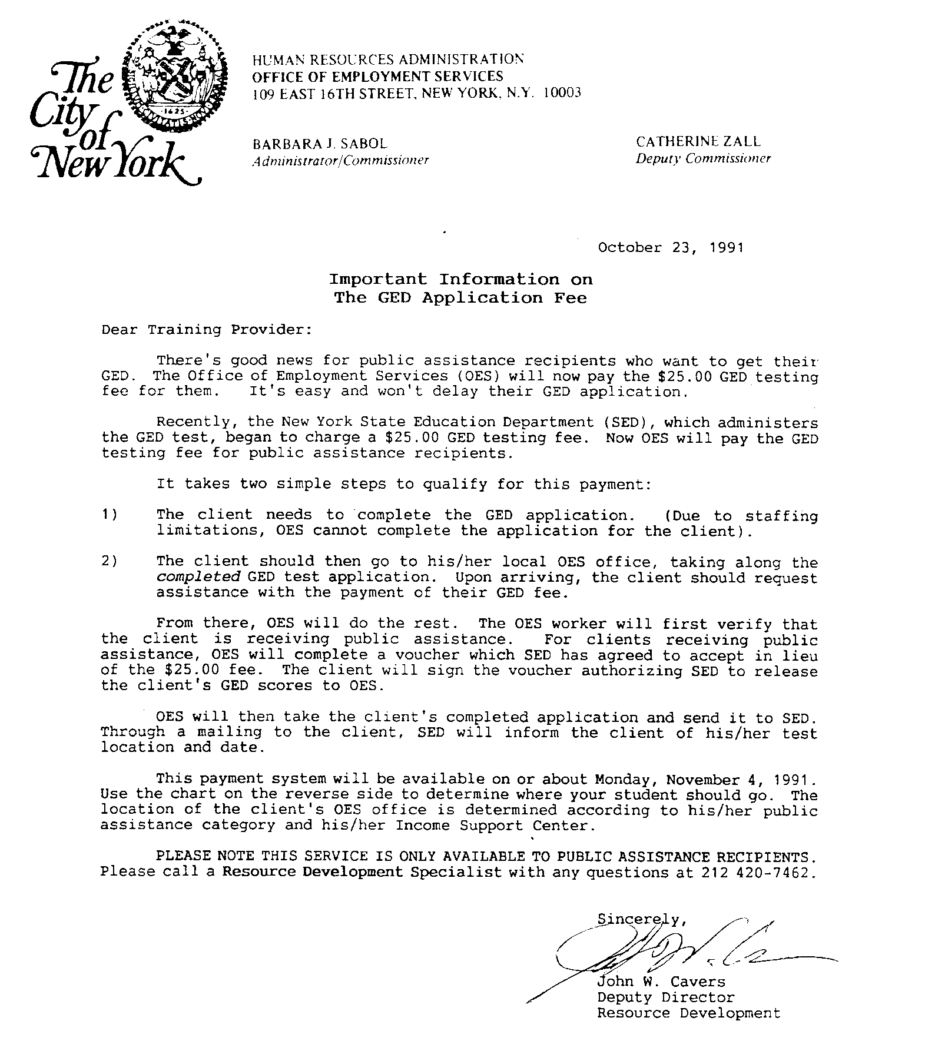
Figure 14 Adult Basic Education Program High School Equivalency Preparation Classes List
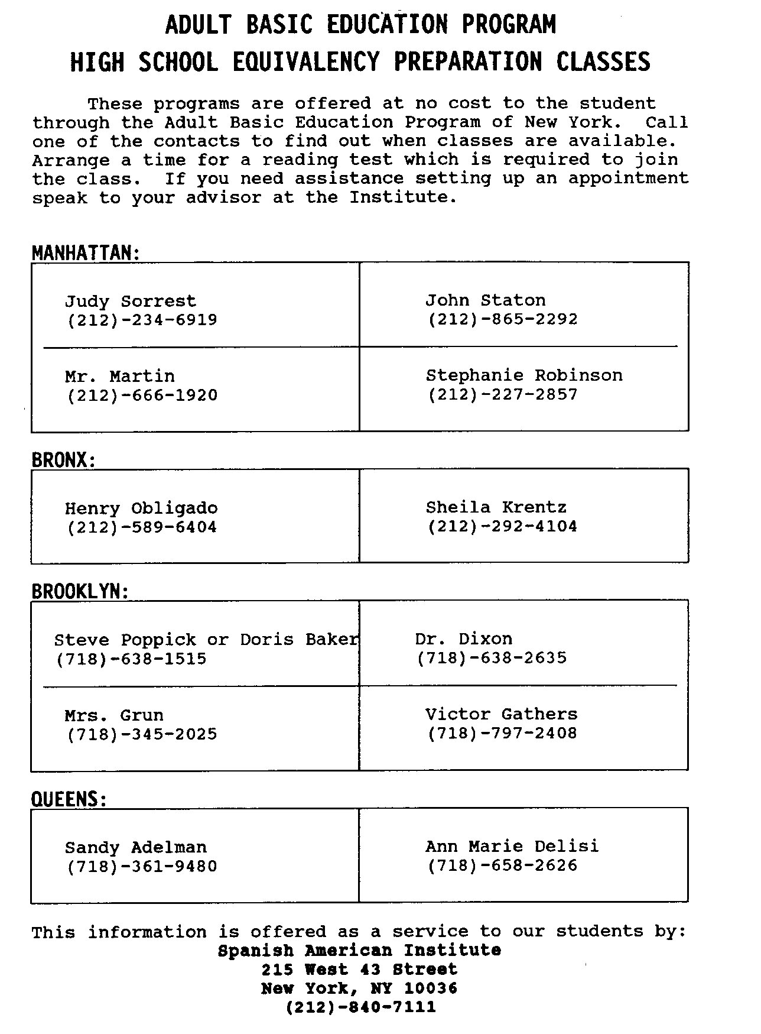
Figure 15 Adult Basic Education Program High School Equivalency Preparation Classes List

Academic Warning Letter
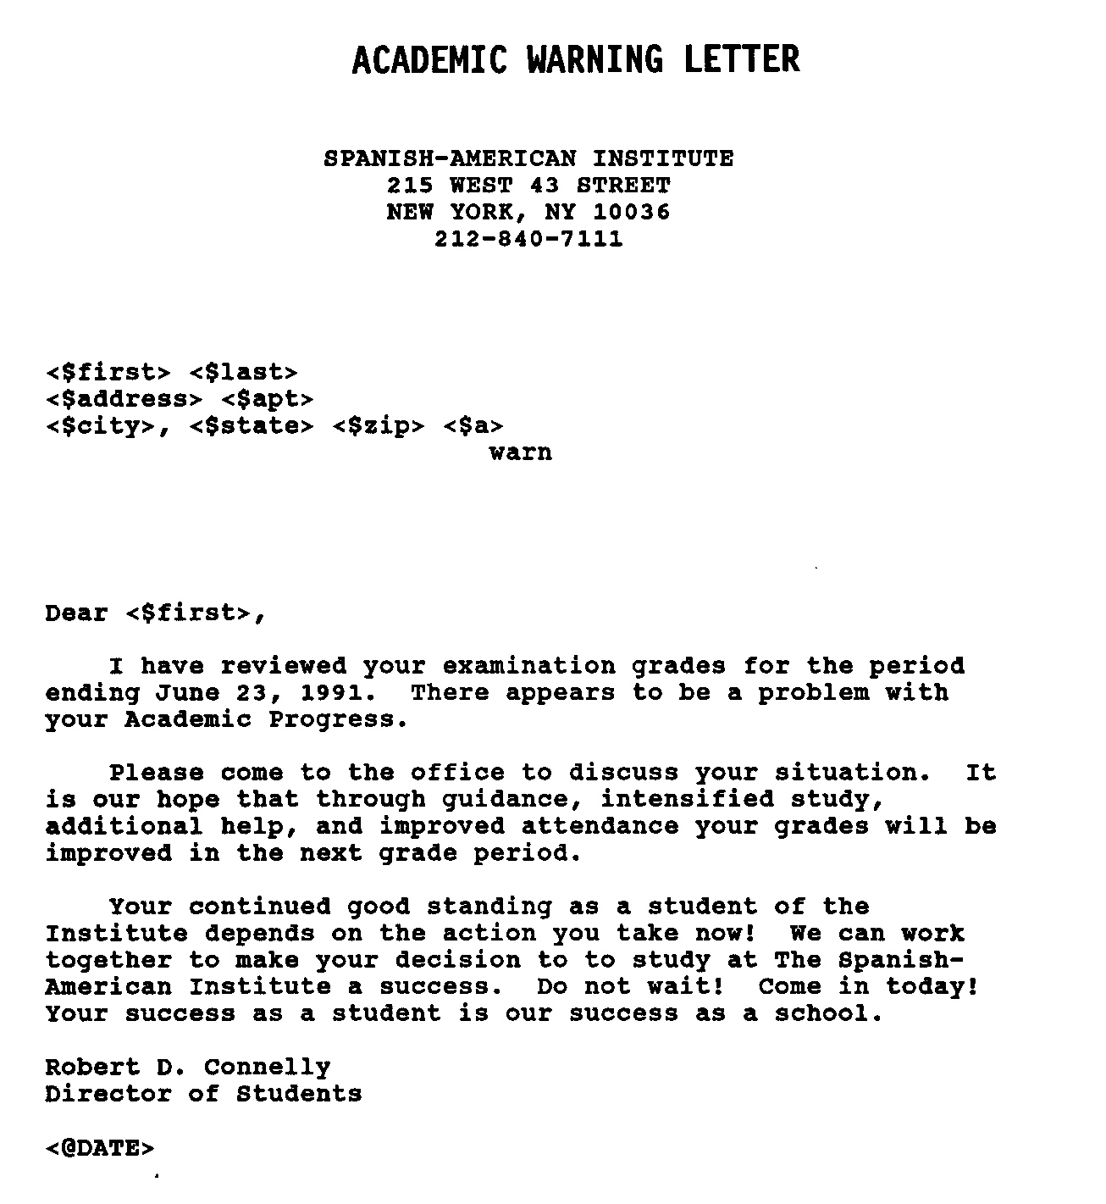
Figure 16 Academic Warning Letter

Progress Report Sample
Figure 17 Progress Report Sample

Program Exit Interview Form for GSL Students
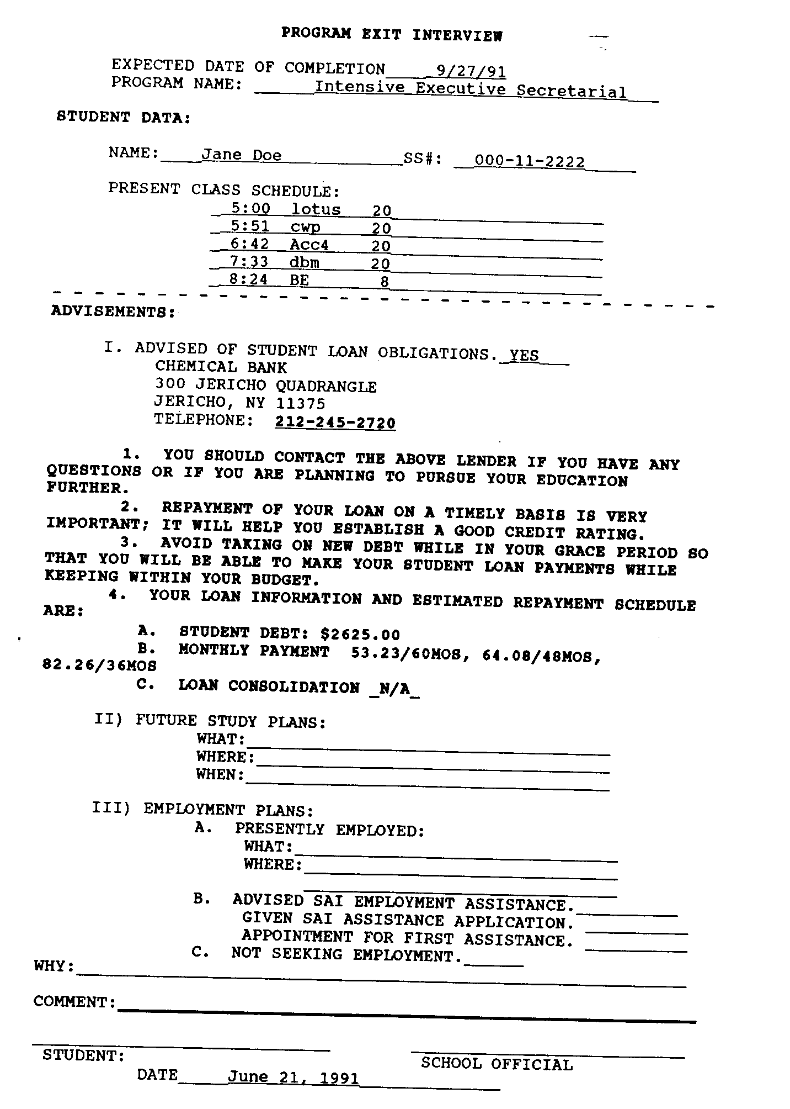
Figure 18 Program Exit Interview Form for GSL Students

Sample Program Planner Form

- Student Placement Assistance Request Form
- Individual Grade Report Form
- Program-Up-date Form
- ESL Level Change Form
- Resource Center Sampler
- Faculty “Welcome Mat” Memo

JUNE 1995

