spanish-american institute
215 West 43 Street ● NYC, NY 10036 ● 212.840.7111 ● fax: 212.719.5922 ● www.sai2000.org ● info@sai2000.org http://www.facebook.com/studentclub
a not-for-profit, equal educational opportunity institution

ESL-Plus Course of Study List of Books and Materials
2012

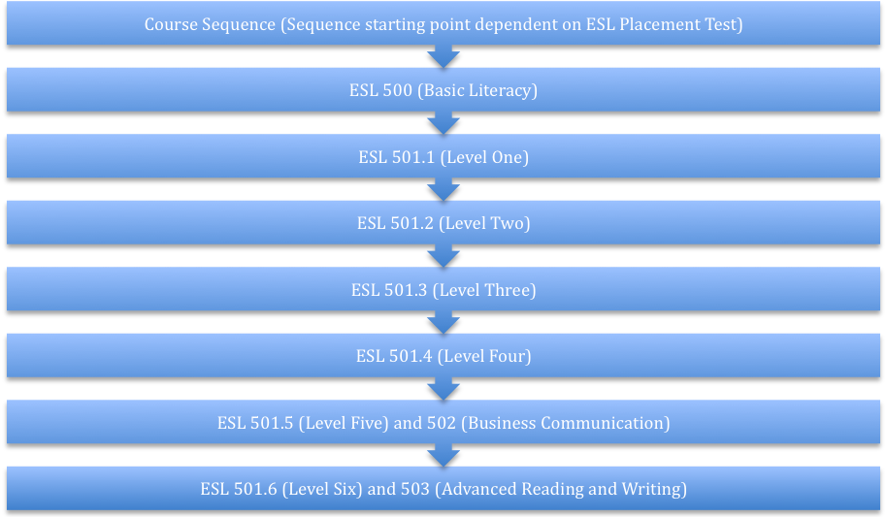

500 English Literacy (120 hours)
Textbook: Longman ESL Literacy, Yvonne Wong Nishio, Pearson Longman, 2006 or comparable text.
(including companion CD/DVD and Teacher Manual with Testing and Evaluation Materials available for instructor loan from the Institute Bookstore)

501.1 English as a Second Language I (120 hours)
Textbook: WorldView 1 (or comparable text), Pearson Education, 2002.
(including companion CD/DVD and Teacher Manual with Testing and Evaluation Materials available for instructor loan from the Institute Bookstore)

501.2 English as a Second Language II (120 hours)
Textbooks: P. Merdinger and L. Barton, NorthStar: Listening & Speaking Level I and Reading & Writing Level I (3rd Edition), Longman, 2009 (or comparable).
(including companion CD/DVD and Teacher Manual with Testing and Evaluation Materials available for instructor loan from the Institute Bookstore)

501.3 English as a Second Language III (120 hours)
Textbook: NorthStar Listening & Speaking Level II and Reading & Writing Level II (3rd Edition., Pearson Education, (or comparable text). (formerly NorthStar: Basic/Low Intermediate)
(including companion CD/DVD and Teacher Manual with Testing and Evaluation Materials available for instructor loan from the Institute Bookstore)

501.4 English as a Second Language IV (120 hours)
Textbook: NorthStar: Listening & Speaking Level III and Reading & Writing Level III 3rd Edition, (or comparable text). (formerly NorthStar: Intermediate)
(including companion CD/DVD and Teacher Manual with Testing and Evaluation Materials available for instructor loan from the Institute Bookstore)

501.5 English as a Second Language V (120 hours)
Textbook: NorthStar: Listening & Speaking and Reading & Writing Level IV, 3rd Edition, (or comparable text). (formerly NorthStar: High Intermediate)
(including companion CD/DVD and Teacher Manual with Testing and Evaluation Materials available for instructor loan from the Institute Bookstore)

501.6 English as a Second Language VI (120 hours)
Textbook: NorthStar: Listening & Speaking and Reading & Writing Level V, 3rd Edition, (or comparable text); Longman Dictionary of American English now with Thesaurus, 3rd or later edition, Pearson, 2004 (recommended). (formerly NorthStar: Advanced)
(including companion CD/DVD and Teacher Manual with Testing and Evaluation Materials available for instructor loan from the Institute Bookstore)

502 Business English (120 hours)
Textbooks: NorthStar: Reading and Writing 4, 3rd Edition., Pearson Education, (or comparable text). Longman Dictionary of American English now with Thesaurus, 3rd or later edition, Pearson, 2004 (recommended).
(including companion CD/DVD and Teacher Manual with Testing and Evaluation Materials available for instructor loan from the Institute Bookstore)

503 Advanced Reading and Writing (120 hours)
Textbooks: NorthStar 5 Reading and Writing Level 5, 3rd ed., Pearson Education, 2009 (or comparable text); Longman Dictionary of American English now with Thesaurus, 3rd or later edition, Pearson, 2004 (recommended).
(including companion CD/DVD and Teacher Manual with Testing and Evaluation Materials available for instructor loan from the Institute Bookstore)

