4.1 | Say whether you agree or disagree with the Court's decision in Part 1.2.

1.

4.2 | Give two reasons to support your opinion using expressions of confidence.

2.

4.3 | Dealing with Misbehavior  Speak for 1-2 minutes. Imagine you work for the Jones Center for Family Causes. This center helps parents and children deal with family problems. Talk to a parent who came to the center about how to deal with the problematic behavior (stealing) of her child.

- Take notes
- Use the present perfect tense.
- Be sure to pronounce final /s/ and /z/ properly.
- Use expressions of confidence.
- Use the vocabulary and grammar from Unit 10.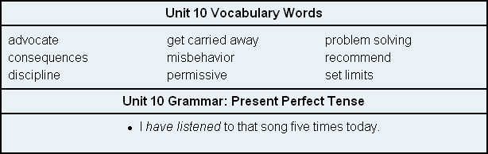

3.

