4.1 | Listen to this phone recording. Is the statement below true, false, or not given?

__________ | 1. | Greta's phone message is about her experience with identity theft.
a. | true
b. | false
c. | not given

4.2 | Write two kinds of advice that you would give to Greta. Then record your advice. Use these expressions.

 | 2. | She should…  She ought to…  She had better…  She shouldn't…

4.3 | Giving Advice
 | Speak for 1-2 minutes. Explain what you would tell a friend to do if he/she were a victim of identity theft.
- Take notes.
- Give 2 kinds of advice suggesting what your friend should do.
- Use modals of advice.
- Use the vocabulary and grammar from Unit 2.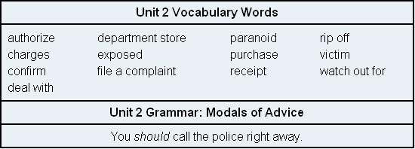

3.

