4.1 | Say an aphorism that you would use to describe your attitude. See the example aphorism below.

 | 1. | My favorite saying is “You can soar on the wings of an optimistic attitude.”

4.2 | Say one brief opinion statement about why you chose that aphorism.

 | 2. | I think that… / I believe that…__________________________________

4.3 | Sharing Your Hobby
 | Speak for 1-2 minutes. Explain an activity (e.g., playing sports, dancing, playing music) that you enjoy doing.
- Take notes.
- Refer to the listening from Part 1.2.
- Include your personal aphorism and your opinion.
- Use reflexive and reciprocal pronouns.
- Use expressions with other.
- Use the vocabulary and grammar from Unit 3.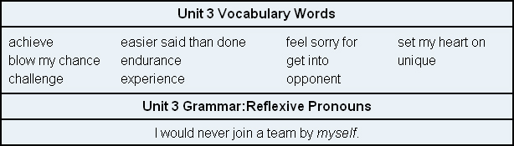

3.

