4.1 | Say one thing you would do when leading a discussion.

1.

4.2 | Say one thing you would not do when leading a discussion.

2.

4.3 | Leading a Discussion
 | Speak for 1-2 minutes. Explain how you would lead a classroom discussion about language learning.
- Take notes.
- Use modals of ability and possibility.
- Be sure to pronounce can and can't correctly.
- Use the vocabulary and grammar from Unit 4.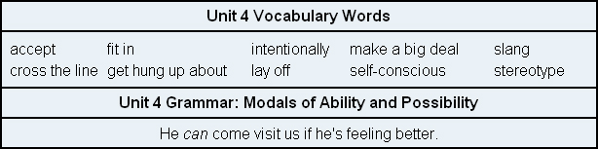

3.

