4.1 | Say one emotion that the main character from Part 1.2 did not feel.

1.

4.2 | Say one way the story would have been different in the main character had not thrown everything into the trash can.

2.

4.3 | Re-telling a Story
 | Speak for 1-2 minutes. Imagine that the main character had not thrown everything into the trash can. Re-tell the story.
- Take notes.
- Refer to the listening and information from Part 1.2.
- Use various storytelling techniques.
- Use transition words and phrases to give information about the time when events happen in the story.
- Use the vocabulary and grammar from Unit 6.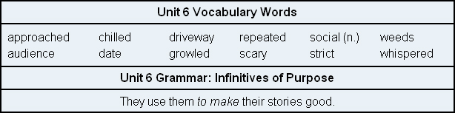

3.

