4.1 | Say what the person's simple pleasure is in Part 1.2.

1.

4.2 | Say how this routine makes her feel.

2.

4.3 | Describing a Simple Pleasure  Speak for 1-2 minutes about a simple pleasure that you enjoy doing, either alone or with friends.
- Take notes. Refer to the listening and information from Part 1.2.
- Use nouns and quantifiers correctly.
- Use adjectives and adverbs, specific information, and words that appeal to the senses.
- Use the vocabulary and grammar from Unit 7.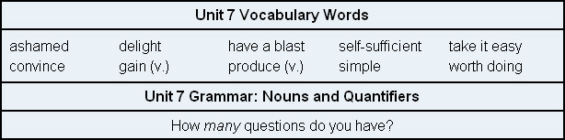

3.

