4.1 | Imagine that you agree with Suzanne from Part 1.2. Say a reason why you support what she is saying.

1.

4.2 | Now imagine that you agree with Amani. Say a reason why you support what she is saying.

2.

4.3 | Presenting Both Sides of an Issue  Speak for 1-2 minutes. Present both views to the class. State Suzanne and Amani's opinions about writing down your expectations before getting married. Then give your opinions. Support your opinions with examples. Make a concluding sentence.

- Take notes.
- Use comparatives and equatives.
- Emphasize words that show a contrast.
- Use transitions for introducing main ideas and supporting points.
- Use the vocabulary and grammar from Unit 8.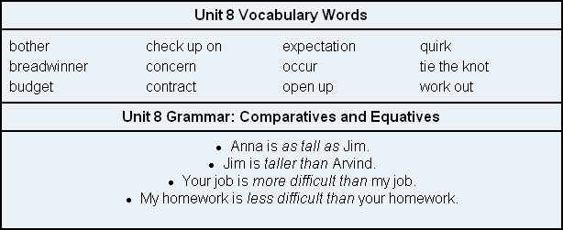

3.

