4.1 | Explain the term "carbon footprint."

1.

4.2 | Think about a suggestion the speaker did not mention. Say your suggestion using must not.

2.

4.3 | Helping the Environment  Speak for 1-2 minutes. Give your own suggestions for how individuals, industries, or governments can help the environment. Tell your classmates that they can interrupt you politely to ask questions.

- Give at least two suggestions.
- Use modals of necessity.
- Use proper intonation to indicate that you have more to say or are finished speaking.
- Use the vocabulary and grammar from Unit 9.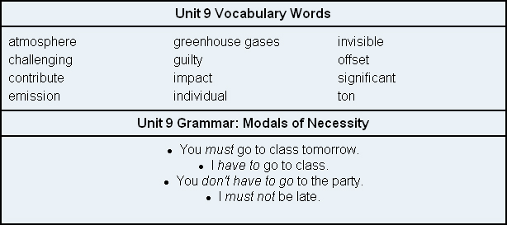

3.

