Links: Additional paintings from the Nuria Rabanillo-De La Fuente exhibit can be viewed on-line on the Spanish-American Institute website at: www.sai2000.org.

Travel Directions: The Spanish-American Institute is located at 215 W. 43rd St. between Broadway and 8th Ave. in Times Square. Take any train that stops at 42nd St./Times Square.

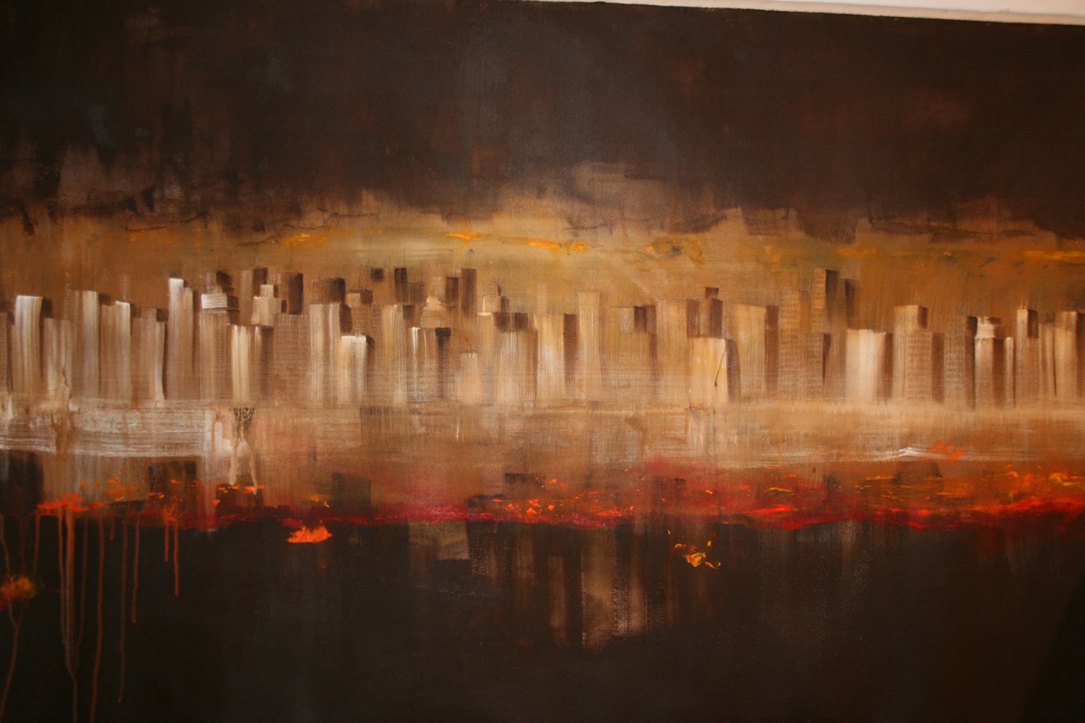

Spanish-American Institute

215 West 43 Street
Times Square, New York 10036-3913

voice: 212.840.7111 fax: 212.719.5922
www.sai2000.org info@sai2000.org
SKYPE: StudentClub
Spanish-American Institute
Student Club
"English Through the Arts" Series

presents

An Exhibition of Selected Works by

Nuria Rabanillo-De La Fuente

10:00am to 9:00pm, Mon.-Fri.

June 1, 2010-June 30, 2010

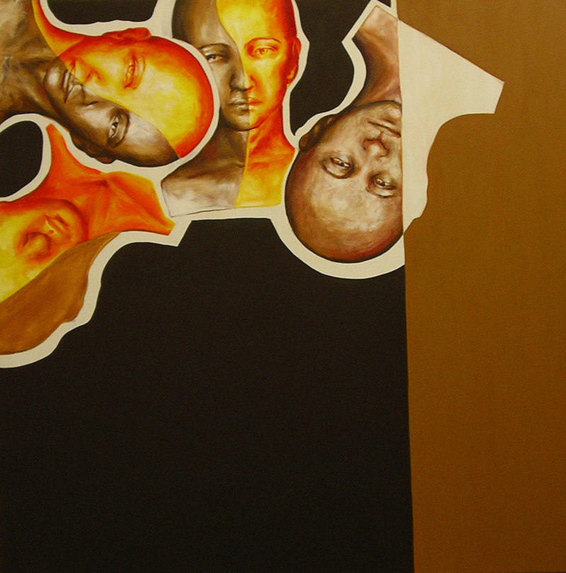

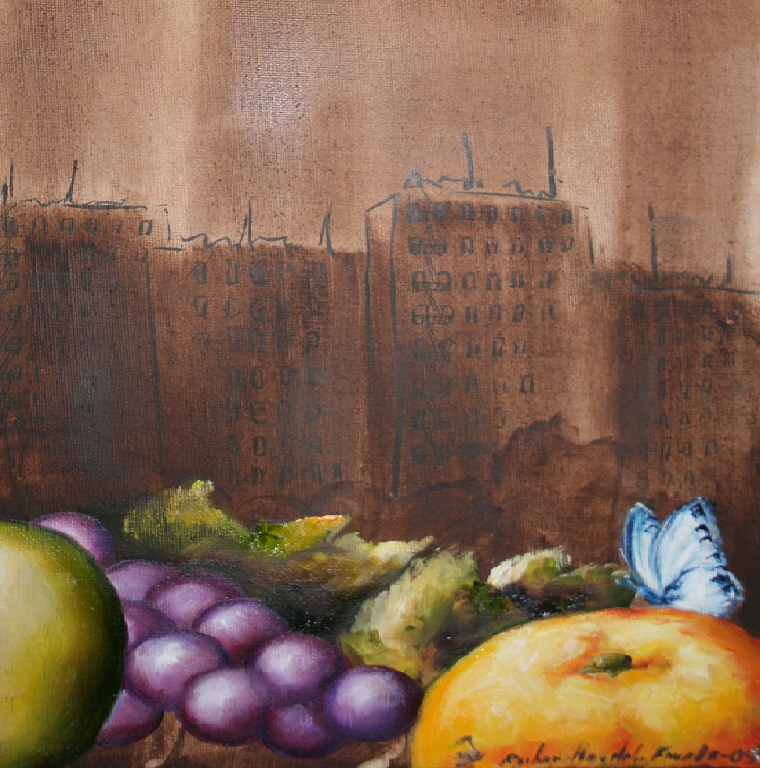

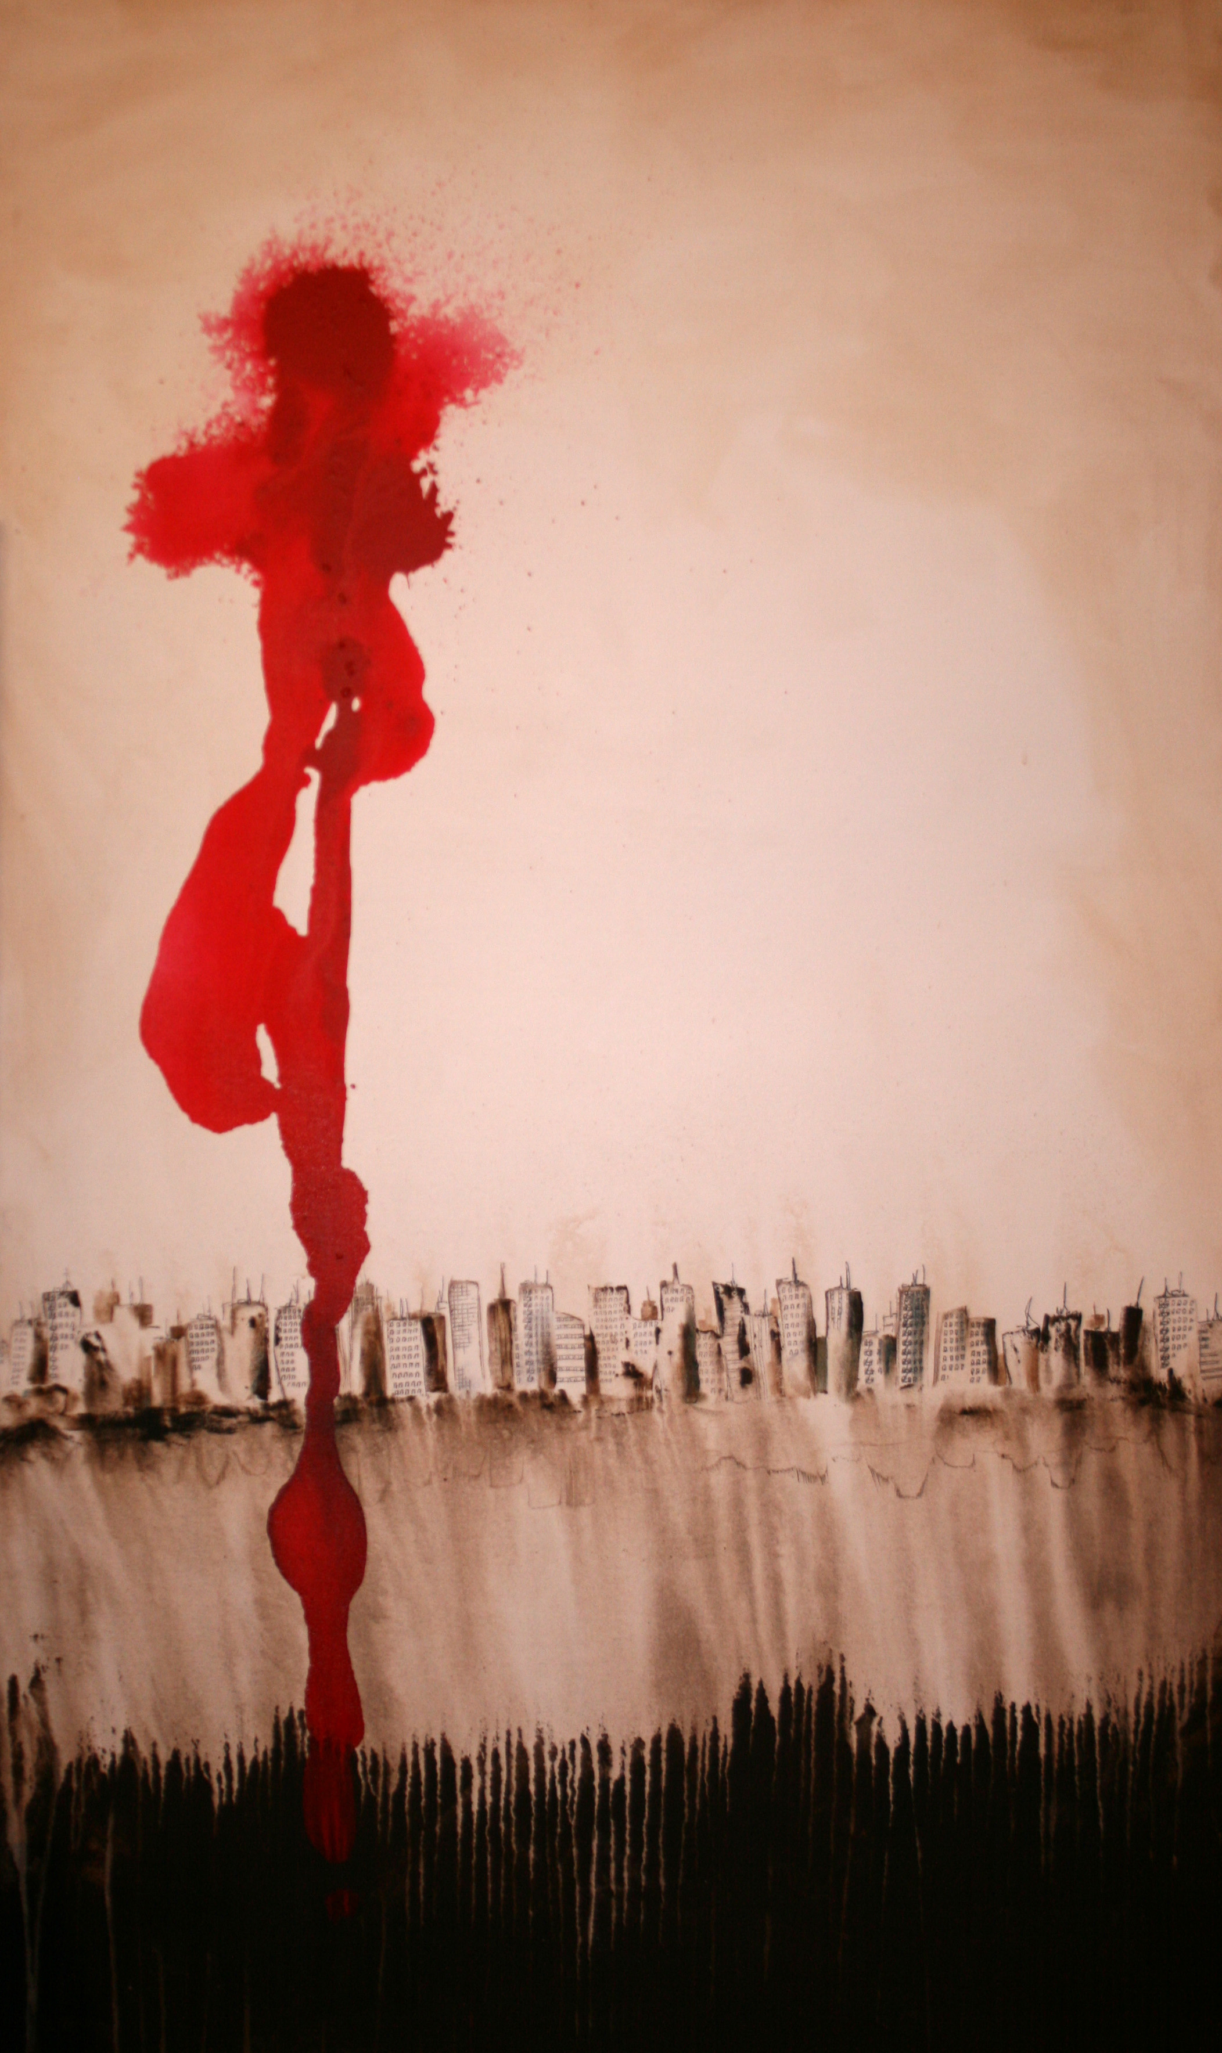

Nuria Rabanillo-De La Fuente

A Spanish-American Institute student, Nuria Rabanillo-De La Fuente was born in Spain where she exhibited widely in major cities, including Madrid, Barcelona, and Valladolid. In New York City, she has shown at the TRA Gallery in Brooklyn and at the Montserrat Contemporary Art Gallery in Manhattan.

Nuria Rabanillo received formal art training in Spain in several mediums. In 1994, the city of Toledo awarded her a young designer’s scholarship to the prestigious Instituto Europeo di Design in Milan, Italy. While in Italy, however, she decided to return to painting as her preferred medium.

Her paintings exhibited at the Spanish-American Institute include reflections of her impressions of New York City.

Artistic Statement

In reviewing her solo show at the Montserrat Gallery, Maurice Taplinger wrote in Gallery&Studio in 2009 that she paints “Everyperson” in the abstract while praising her ability to create a synthesis of older figurative and modern abstract art. He found that “stark tonal contrasts . . . lend her work its formidable presence, with fragmented figurative elements, specifically heads, set against geometric areas of hard-edged color.” Her painting of tall buildings were “awash in acidic hues” that “loom against skies where airplanes and helicopters swarm.”

Nuria Rabanillo’s work on display at the Spanish-American Institute expresses similar facets of our complex and sometimes fragmented modern reality.

