Links: Additional photos from Luis Monje’s exhibit can be found on the Spanish-American Institute web site at: www.sai2000.org.

Travel Directions: The Spanish-American Institute is located at 215 W. 43rd St. between Broadway and 8th Ave. in Times Square. Take any train that stops at Times Square.

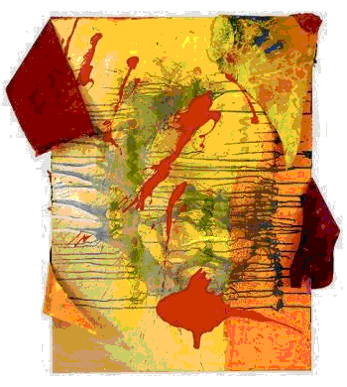

Spanish-American Institute

215 West 43 Street Times Square Manhattan, New York 10036-3913
voice: 212.840.7111 fax: 212.719.5922 www.sai2000.org info@sai2000.org
VoIP internet phone: 166.84.191.135
Spanish-American Institute
Student Club
,
Presents

Luis Monje Exhibit

10:00am to 9:00pm, Mon.-Fri.
October 5-30, 2009
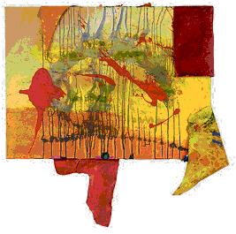

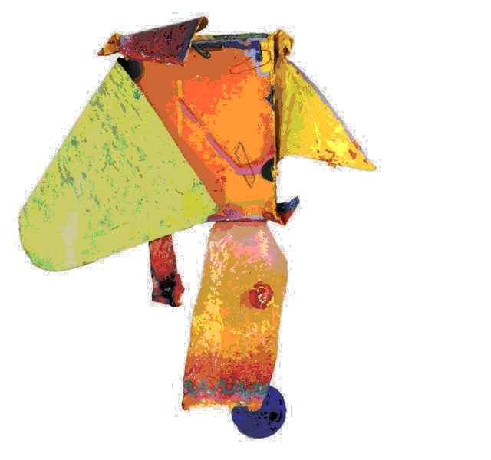

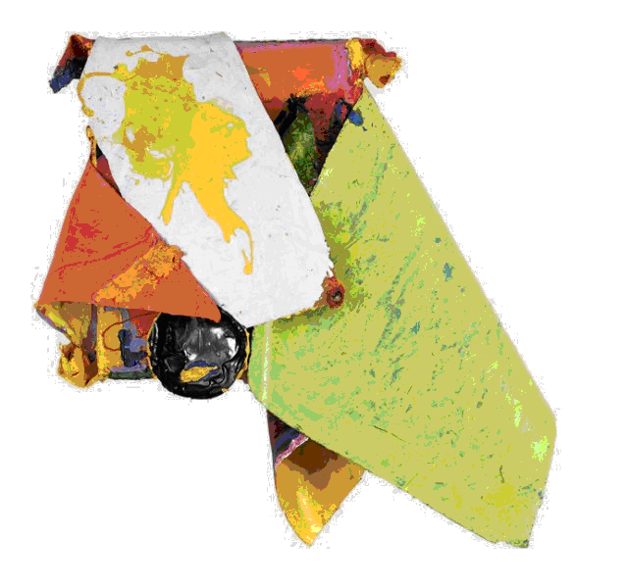

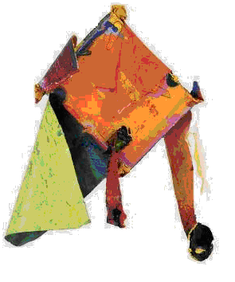

Luis Monje

Born in Columbia in 1951, Luis Monje has lived in New York City since 1976. His first American solo exhibit was in 1997 at the 678 Gallery in New York City. Since then, he has exhibited in many individual and group shows in the North America, Latin America, Europe, and Asia. His work also appears in several public and private collections.

Luis Monje attributes much of the early influences on his work to his childhood with his grandfather, a cabinetmaker whose workshop inspired Luis with its smells, shapes, and creativity. From his service in the Colombian navy, he absorbed the beauty of the sea and sky in ways that would influence his later open and abstract artistic renderings. His formal training includes a Bachelor’s degree in fine arts from City College as well as study at the School of Visual Arts and Arts Student League in New York City.

Artistic Statement
“I work in several media—paintings, drawings, sculptures, and prints. I strive to create works where the viewer can enter a world of color, form, and line from many perspectives.”

“My creations can be rotated by viewers without the limitations of top and bottom, right or left. As a result, viewers can experience four or more distinct compositions in a single art piece, interpreting its forms and colors in their endless possibilities and mutations.”

“For more examples of my work, please visit the Student Club Exhibit.”

