4.1 | Write and say a strong suggestion for keeping elephant attractions in Thailand.

1.

4.2 | Write and say a weak suggestion for keeping elephant attractions in Thailand.

2.

4.3 | Making Suggestions  Speak for 1-2 minutes from a tourist's point of view. Suggest two possible solutions for a compromise between the animal protection group and the tourist about keeping elephant attractions.

- Take notes.
- Refer to your suggestions and the animal protection group's suggestions.
- Make future predictions with if-clauses.
- Use the vocabulary and grammar from Unit 5.
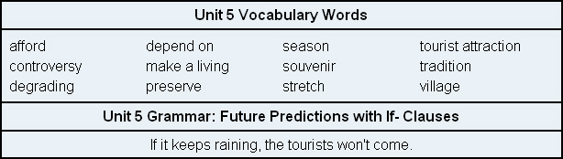

3.

